­­­

[**Comm Network Mgt**](javascript:void(0)) **(CIS 5659)**

**Launch a Static Website on Amazon S3**

Sai Madhuhas Kotini

University of Central Missouri

### **Dr. Shah M A Mumin**

**Web-Page Project:**

Book a ride to the university is a user-friendly platform to book a comfortable ride at your convenience to the university. Its goal is to provide safe, comfortable, and affordable transportation for students.

Requirements:

The webpage consists of HTML Forms and CSS.

The HTML Forms has the following

* User Information: It has name of the students.
* Pick-up and Drop-off Location details.
* Date and Time for the ride requested.
* A button for “Book a Ride” for confirmation of the ride requested.
* A webpage with ride details should display along with “Download confirmation”.
* Upon clicking on the button “Download Confirmation” a text file with user ride details and Confirmation Number should download.

Functionality:

When the user enters all the details on the webpage and clicks on the submit button(Book a ride). The ride details will be displayed on a different webpage with a download confirmation button.

Once the user clicks on the download confirmation button a text file with the ride details will download to the user's device.

Operationalization with screenshots:

Webpage:

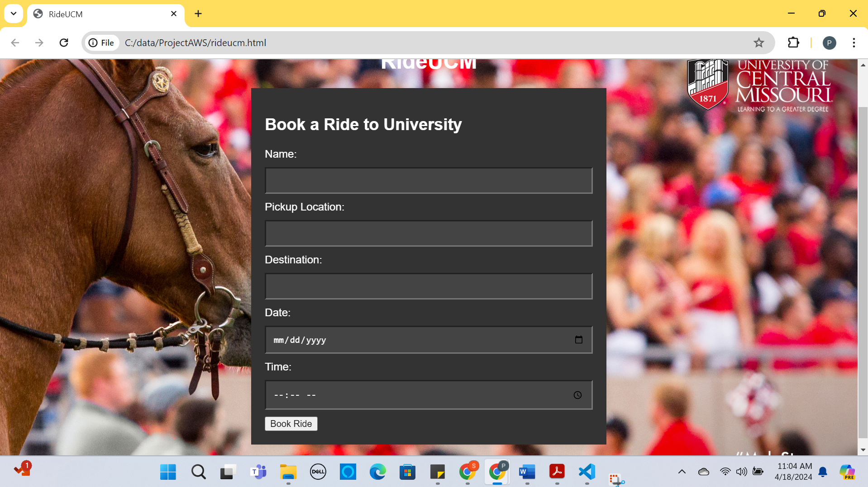

Enter the student details:

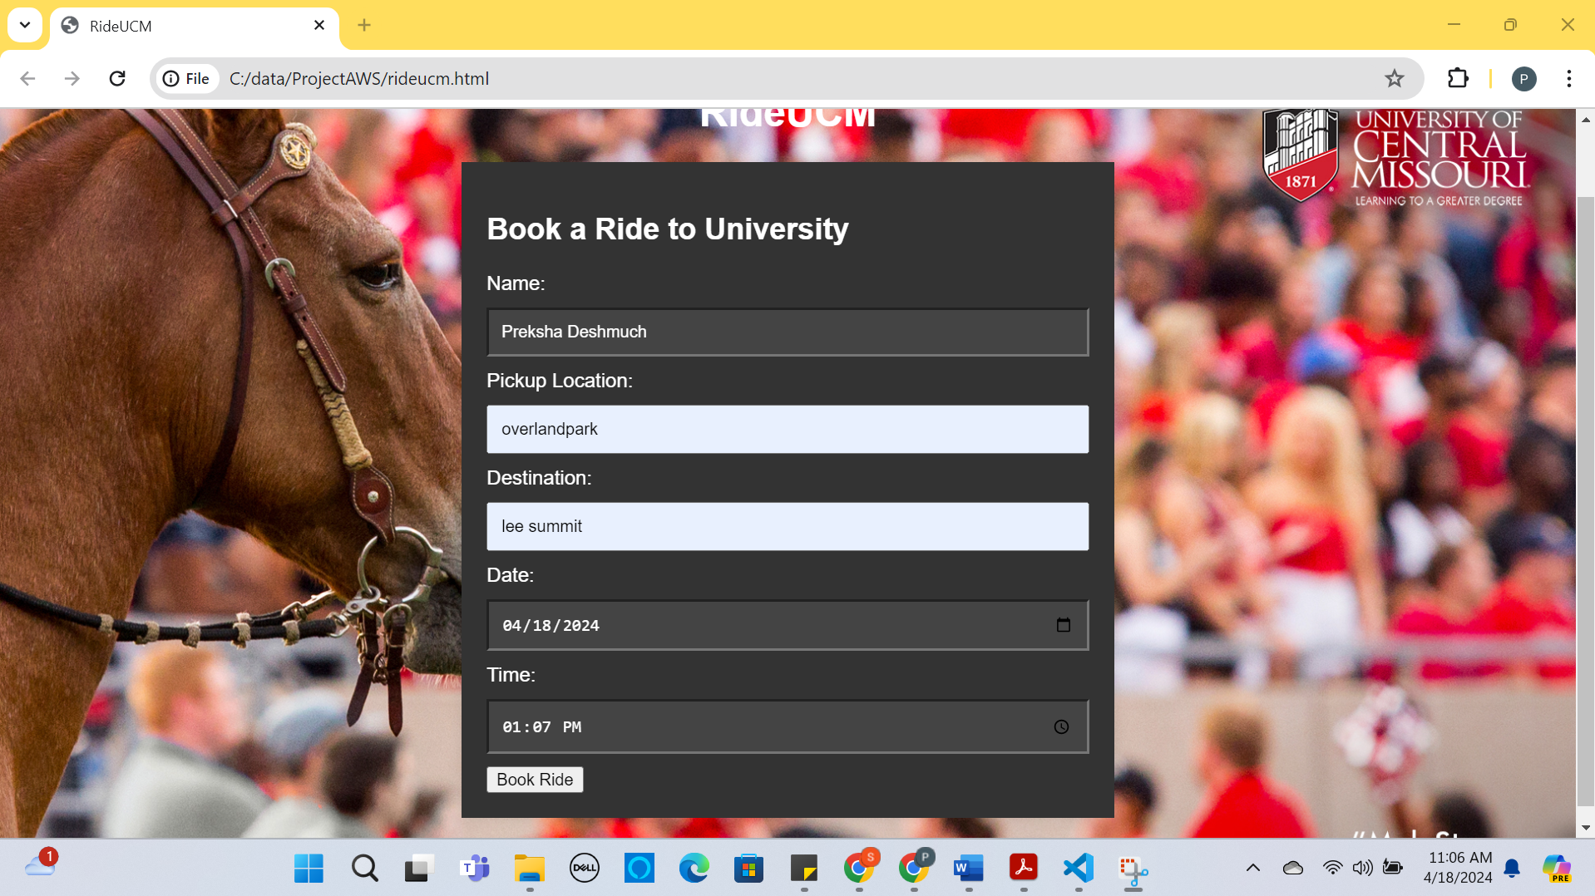

Click on the Book Ride Button:

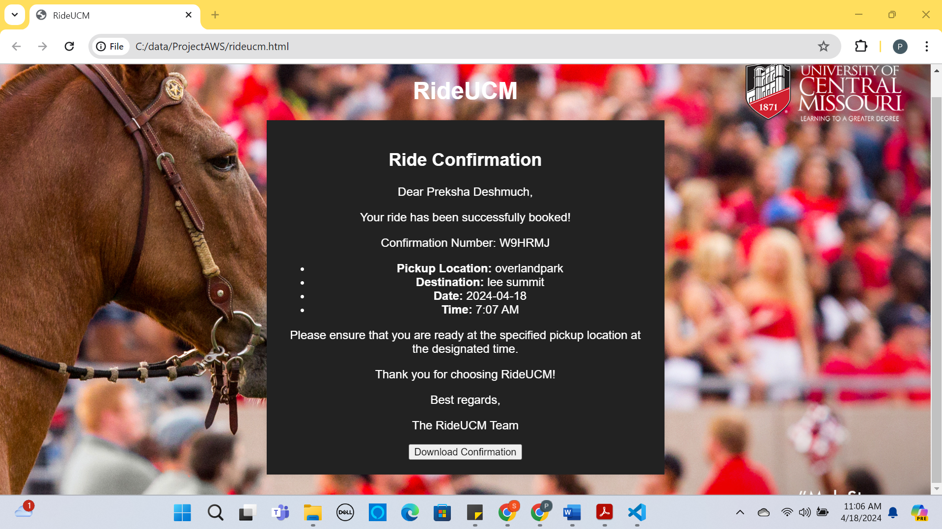

Click on the Download Confirmation:

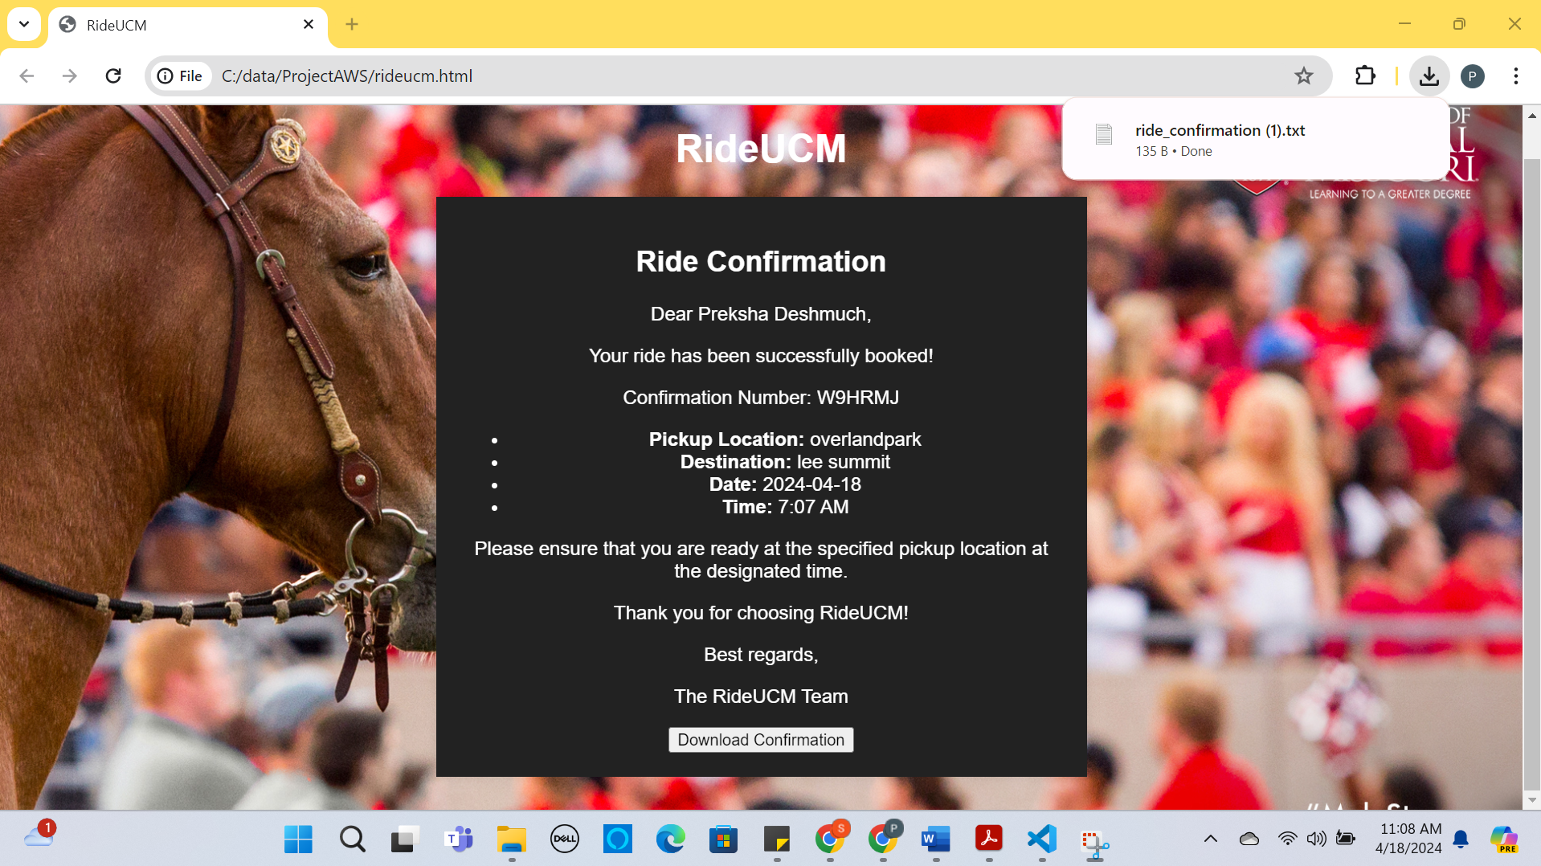

Text File after clicking Download Confirmation

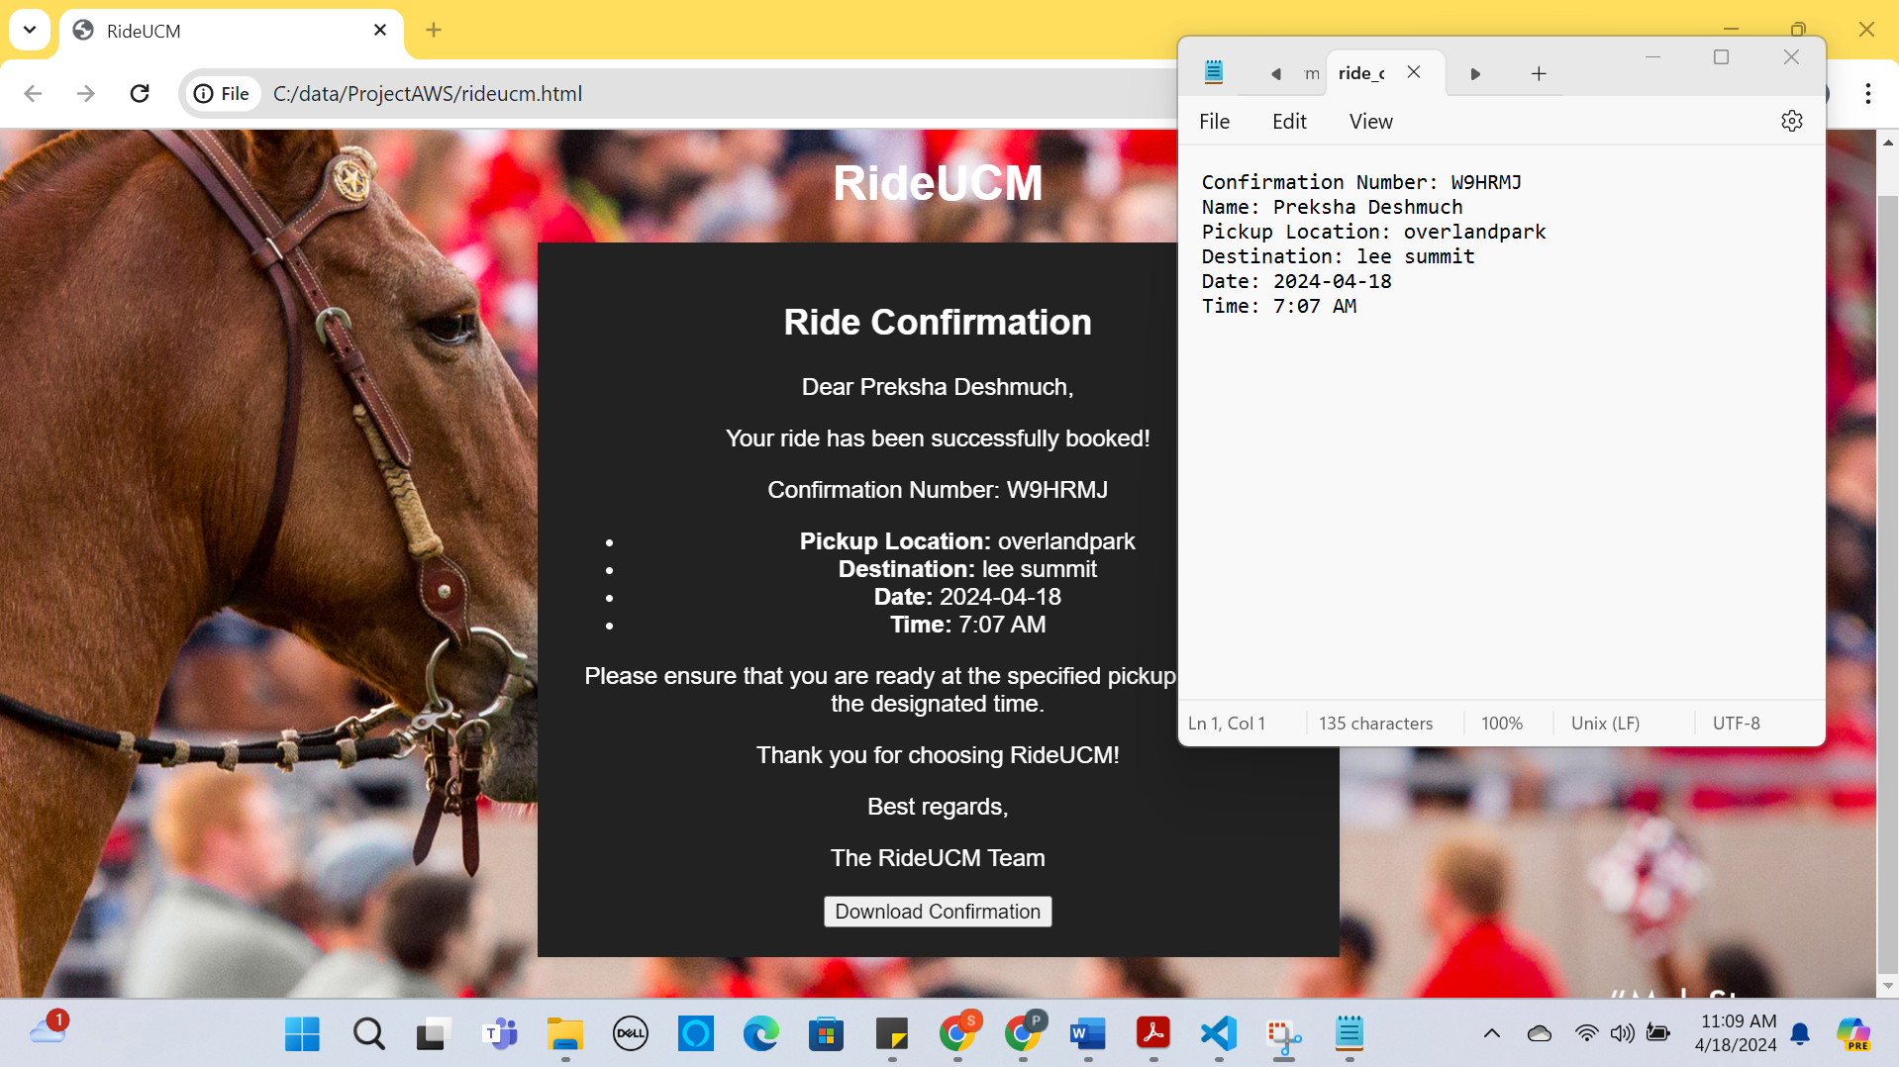

**AWS Services used:**

**S3**

**CloudFront**

**Route 53**

**CloudWatch**

**Certificate Manager**

**Launching a Static website in Amazon S3 Bucket:**

**IAM User: preksha**

**Account Number: 381491822006**

Step 1: Create a S3 Bucket name “rideucm” using Python Boto3.

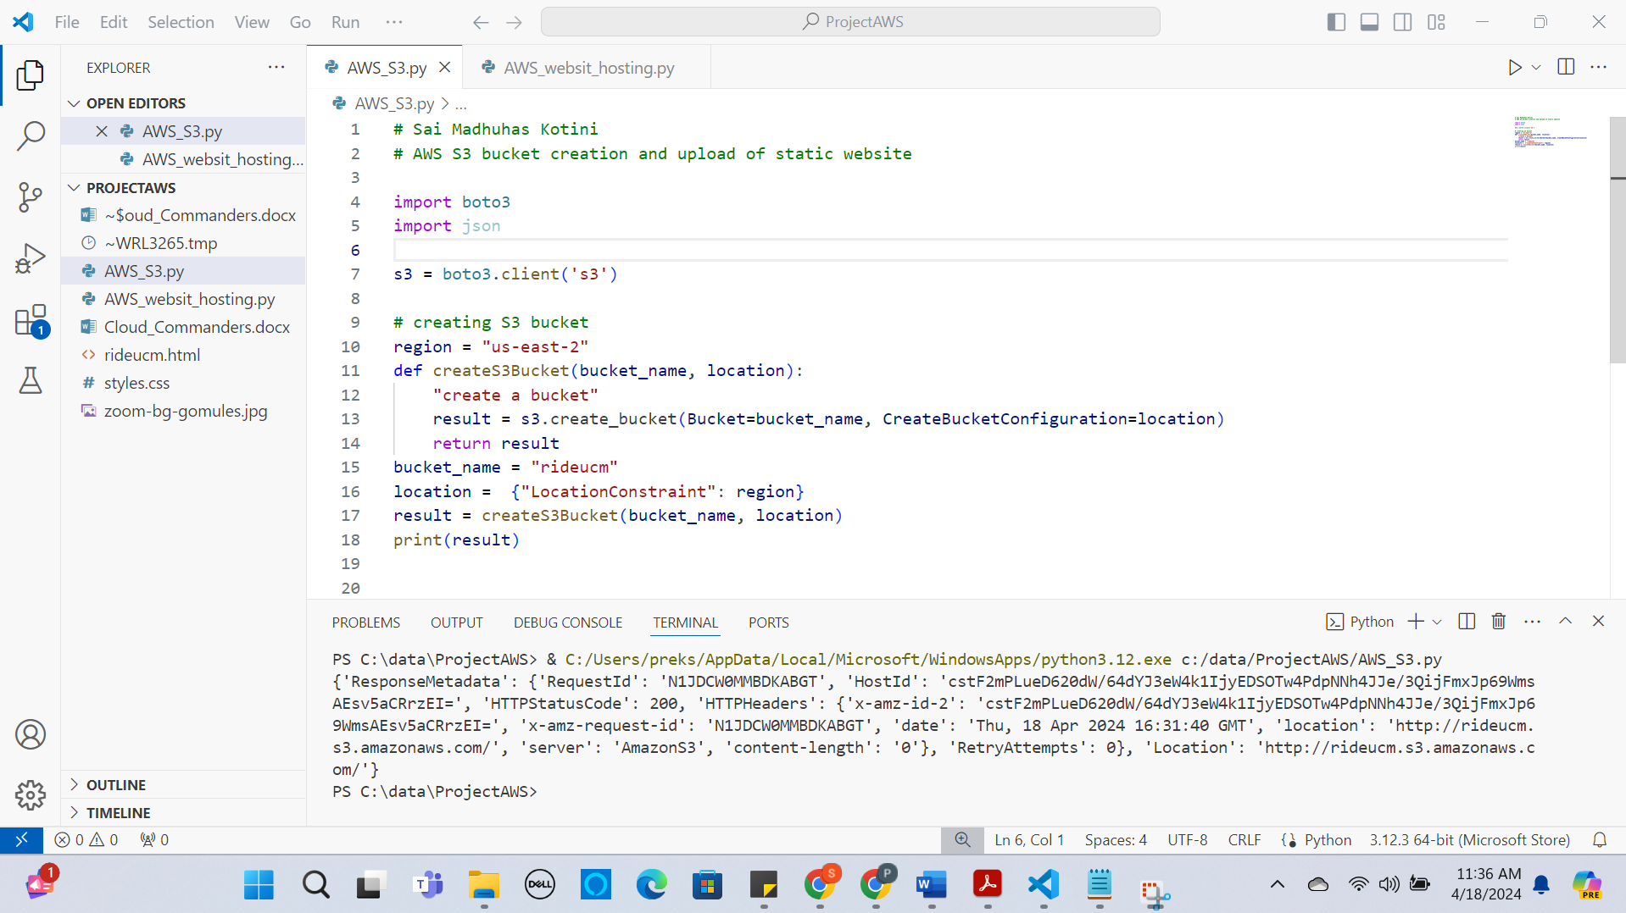

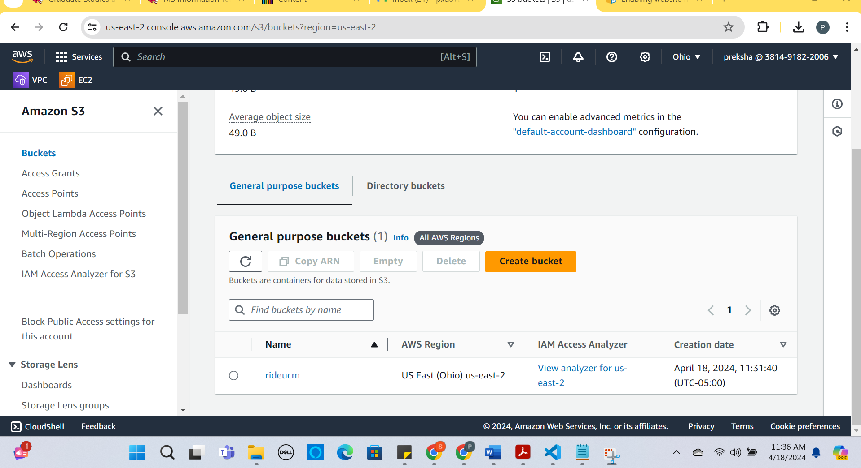

Step 2: Enable Static Website Hosting through AWS console

* Login to the AWS console with IAM user and password.
* Goto the S3 Bucket dashboard.
* Click on the S3 bucket “rideucm” which is created using python boto3.
* Choose Properties.
* 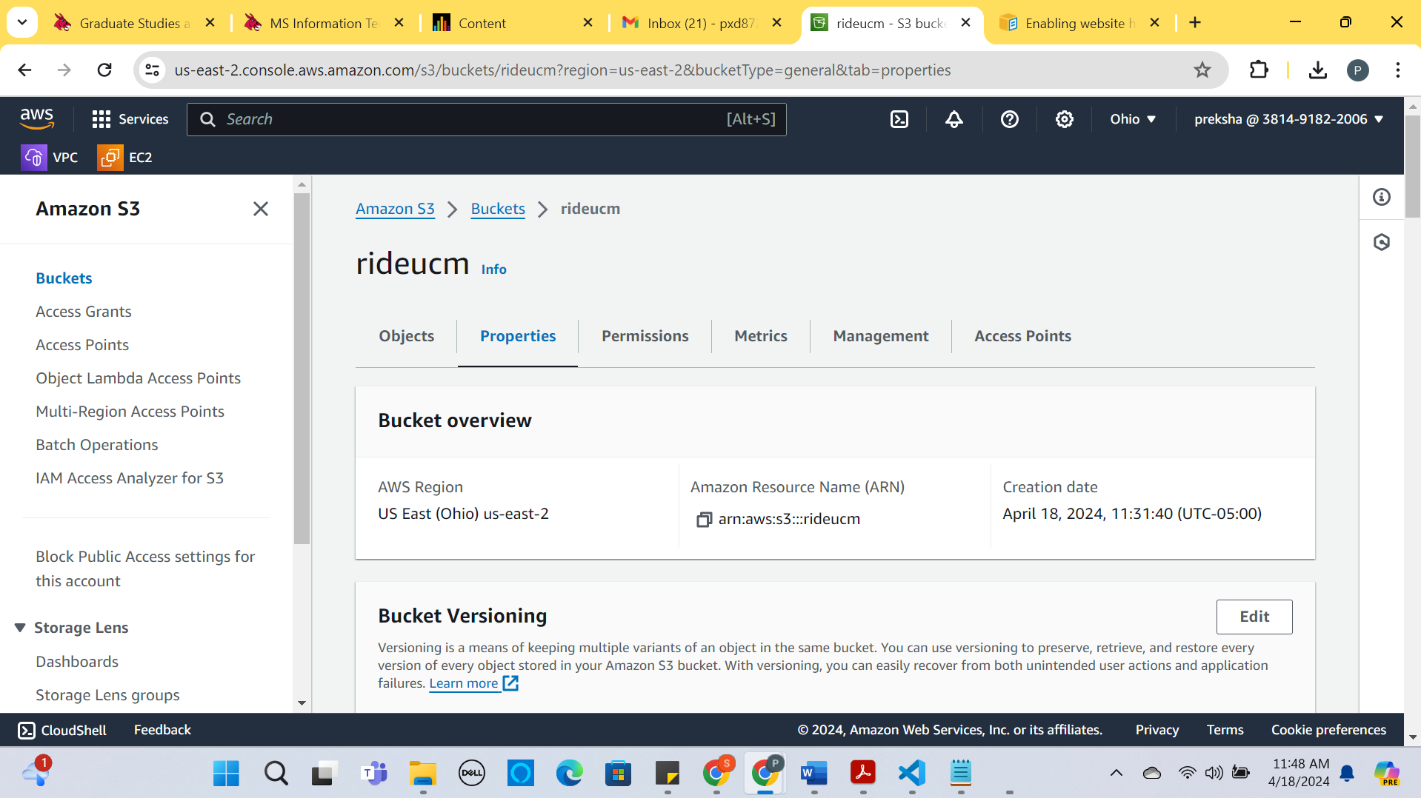
* In the Bucket overview under static website hosting click enable.
* 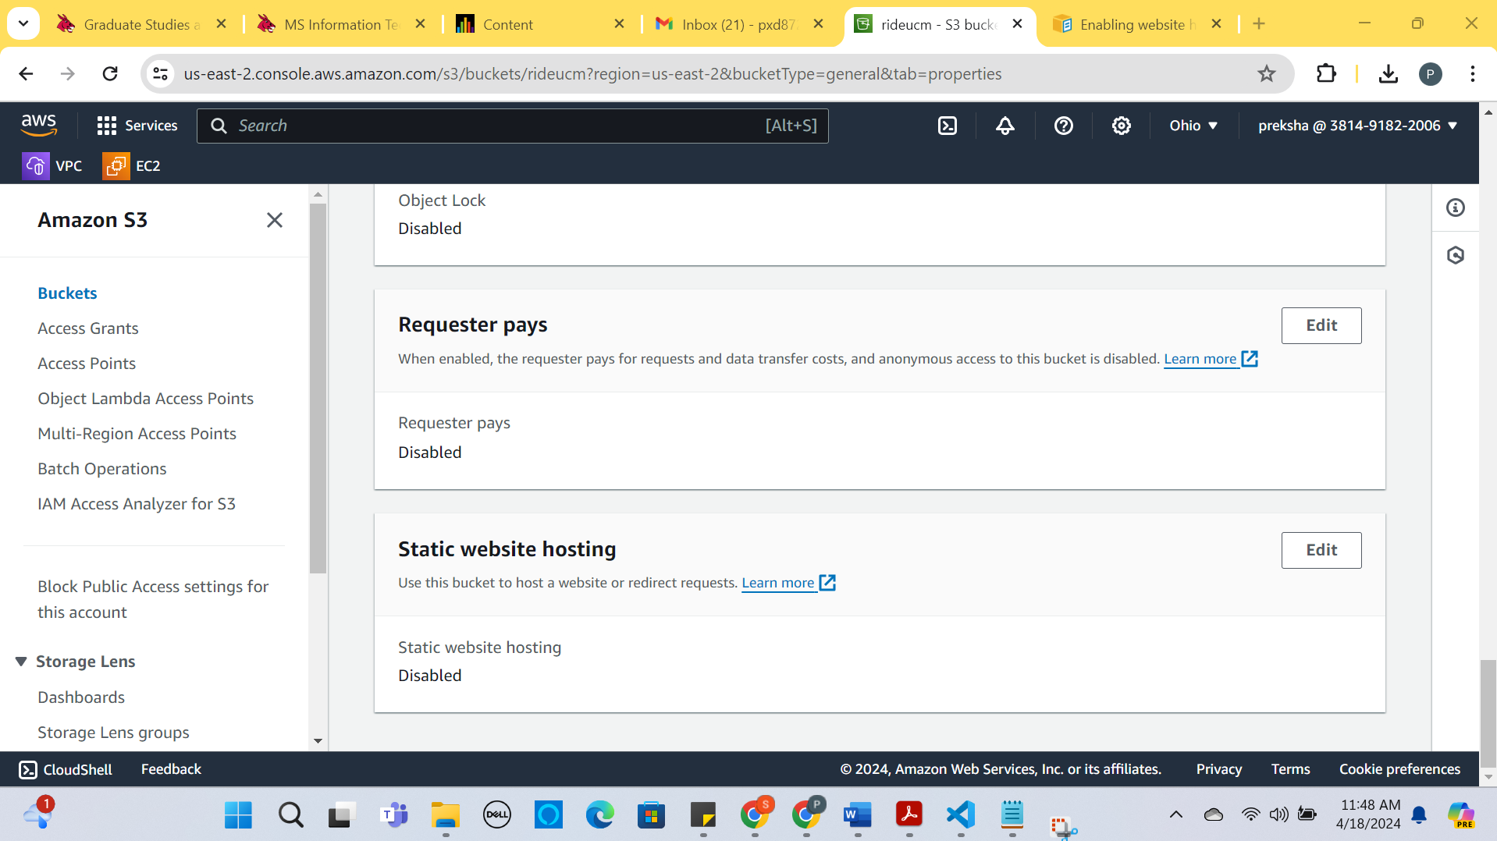
* In the Index document, enter the file name as the webpage name “index.html”.

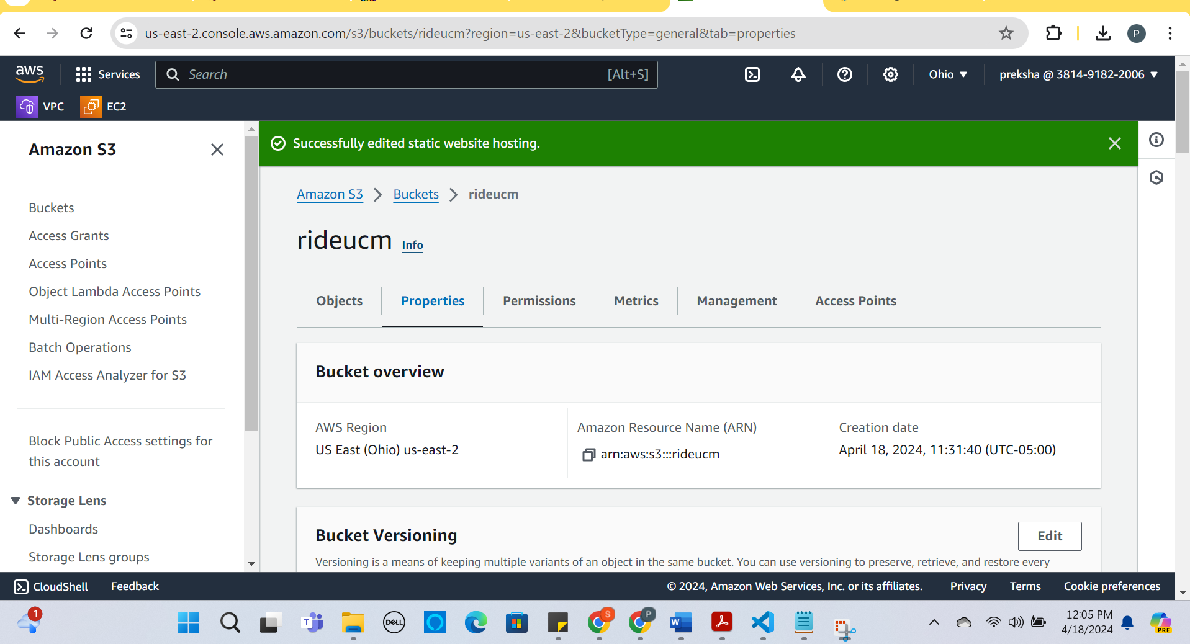

* Click on save changes.

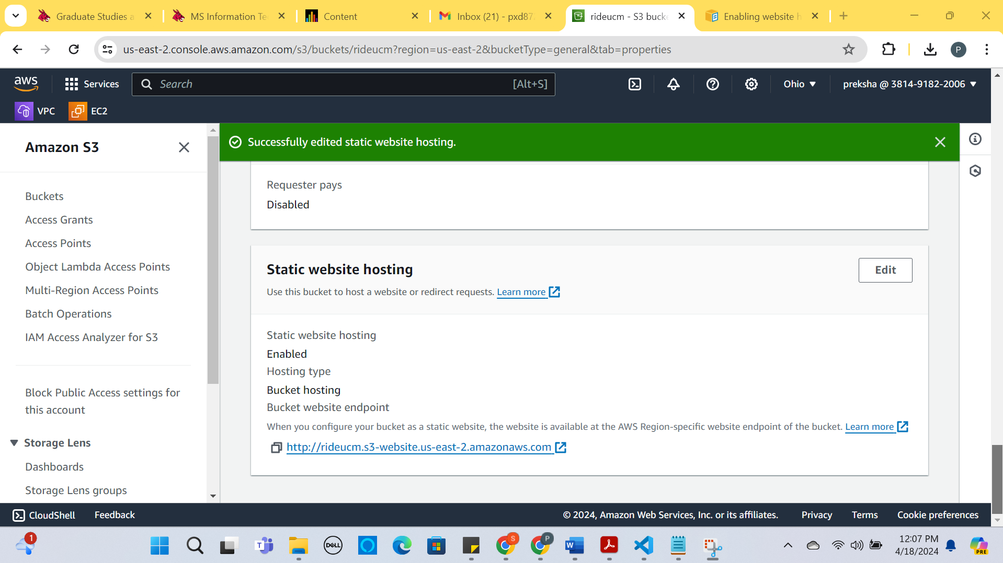

* EndPOint URL:

http://rideucm.s3-website.us-east-2.amazonaws.com

* Enabling public access for the static website.
* Click on the permission tab for the Bucket “rideucm”
* Click on the Edit button for Block Public access settings by default it will be on.

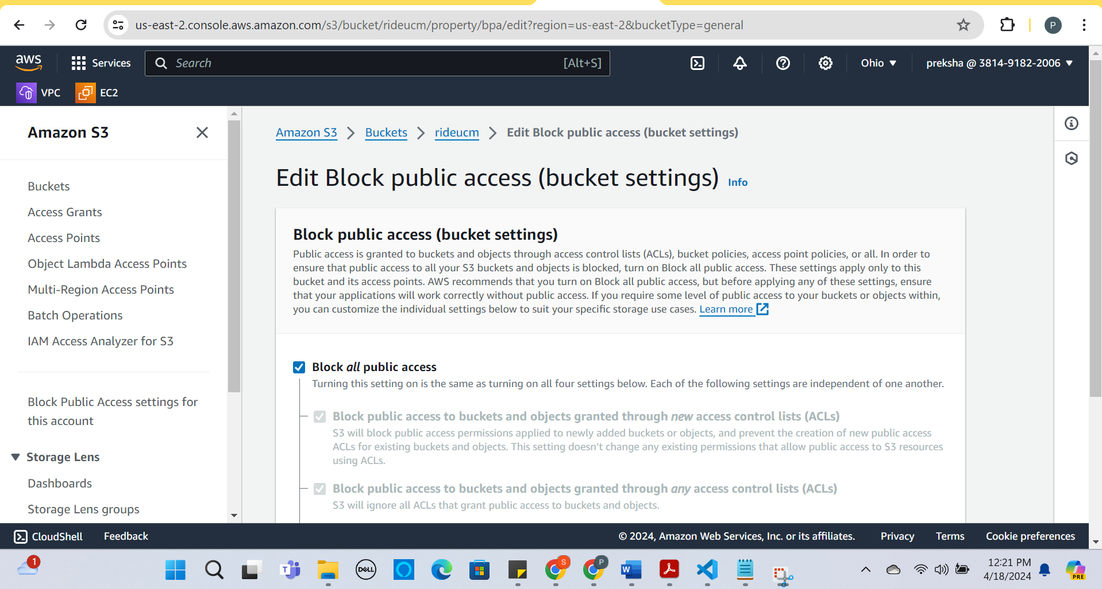

* Uncheck the Block of all public access.

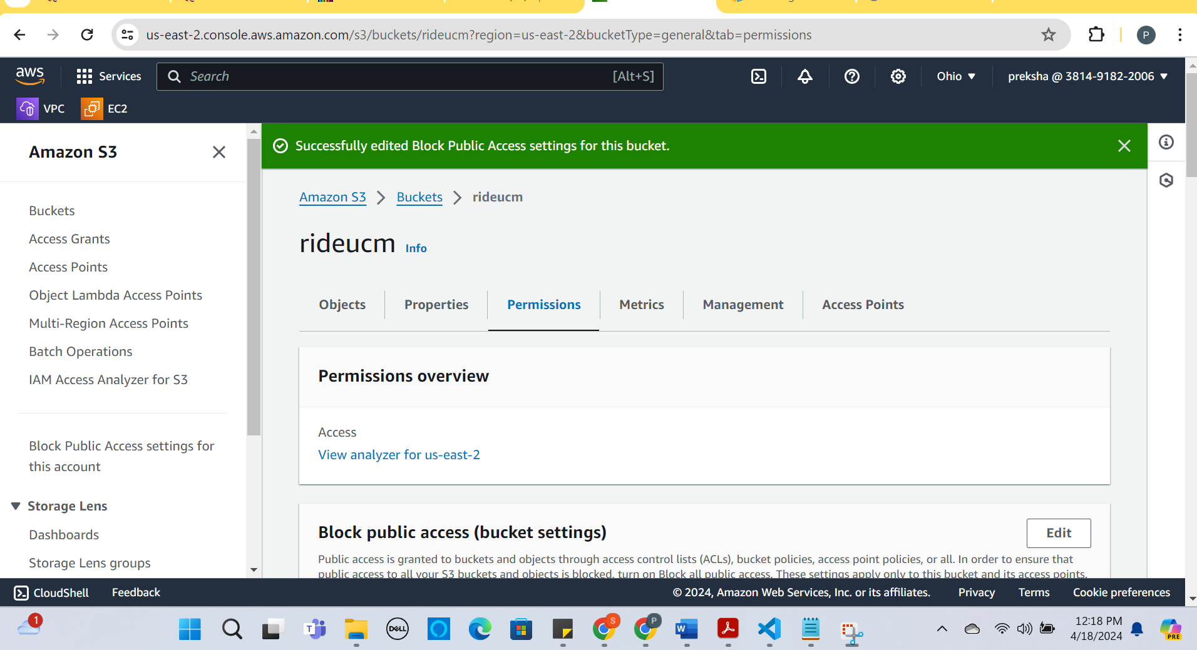

* Set Bucket Policy.

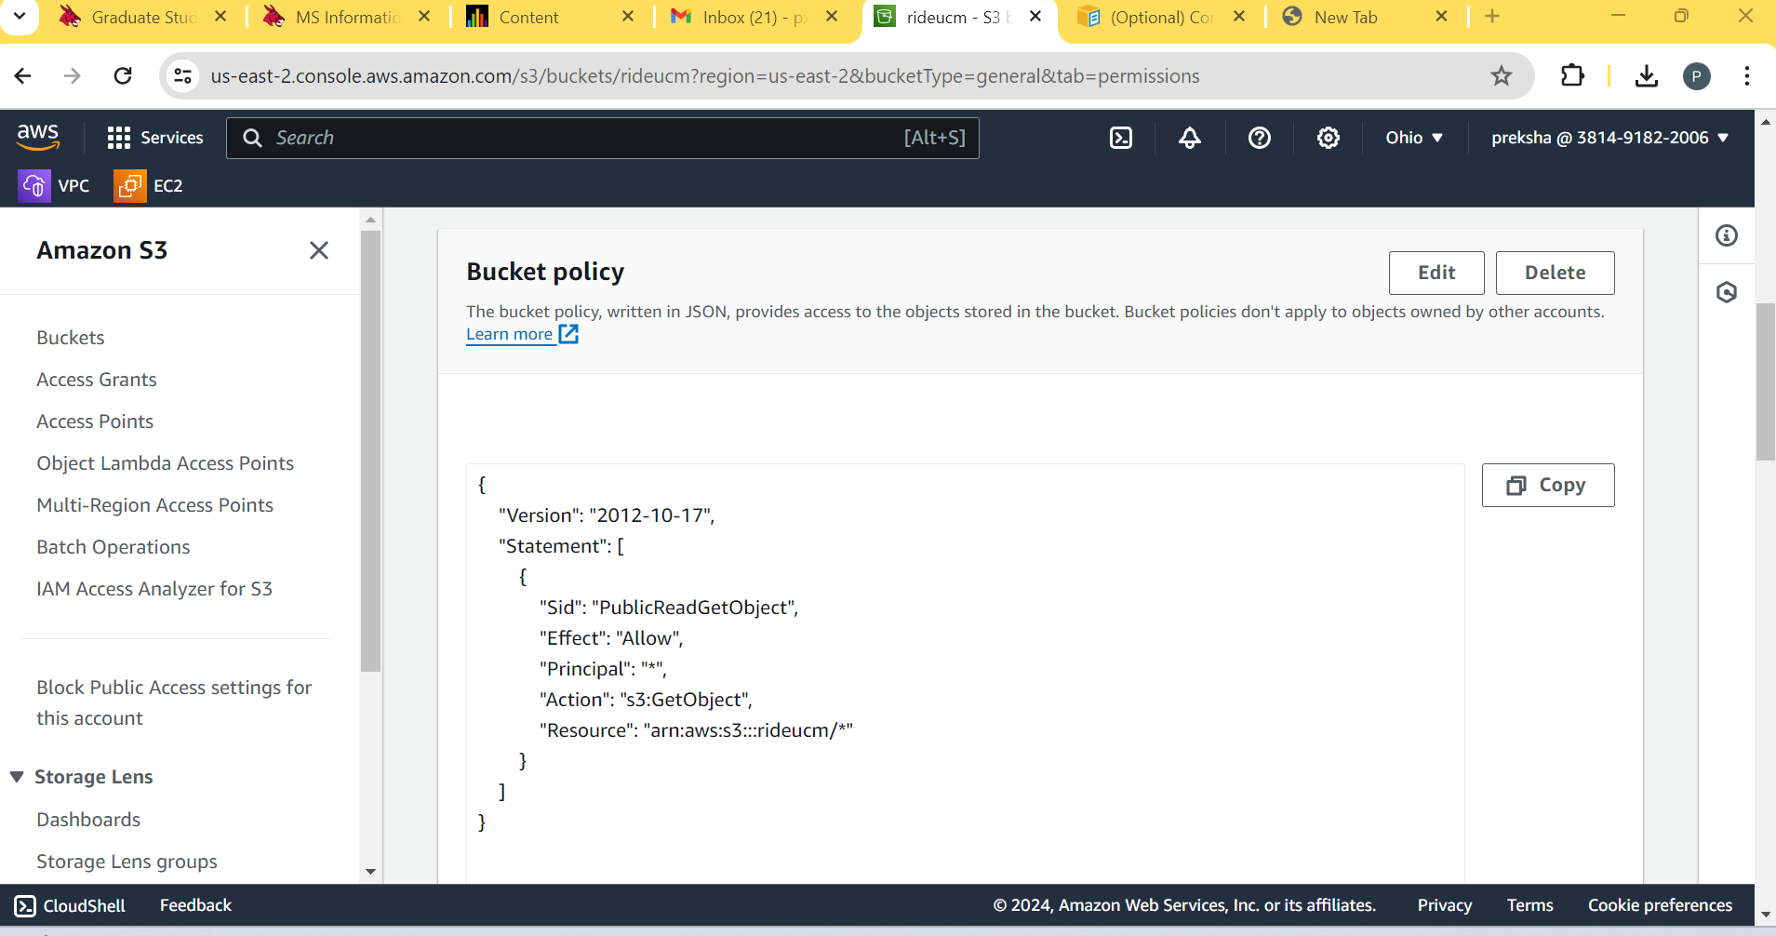

Step 3: Upload the website(webpage) contents in the Se Bucket “rideucm” using Python Boto3.

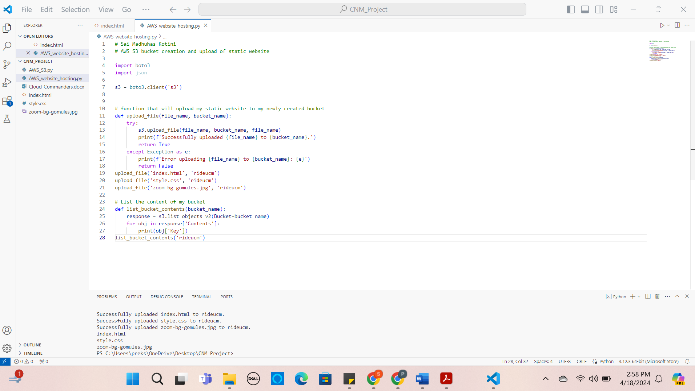

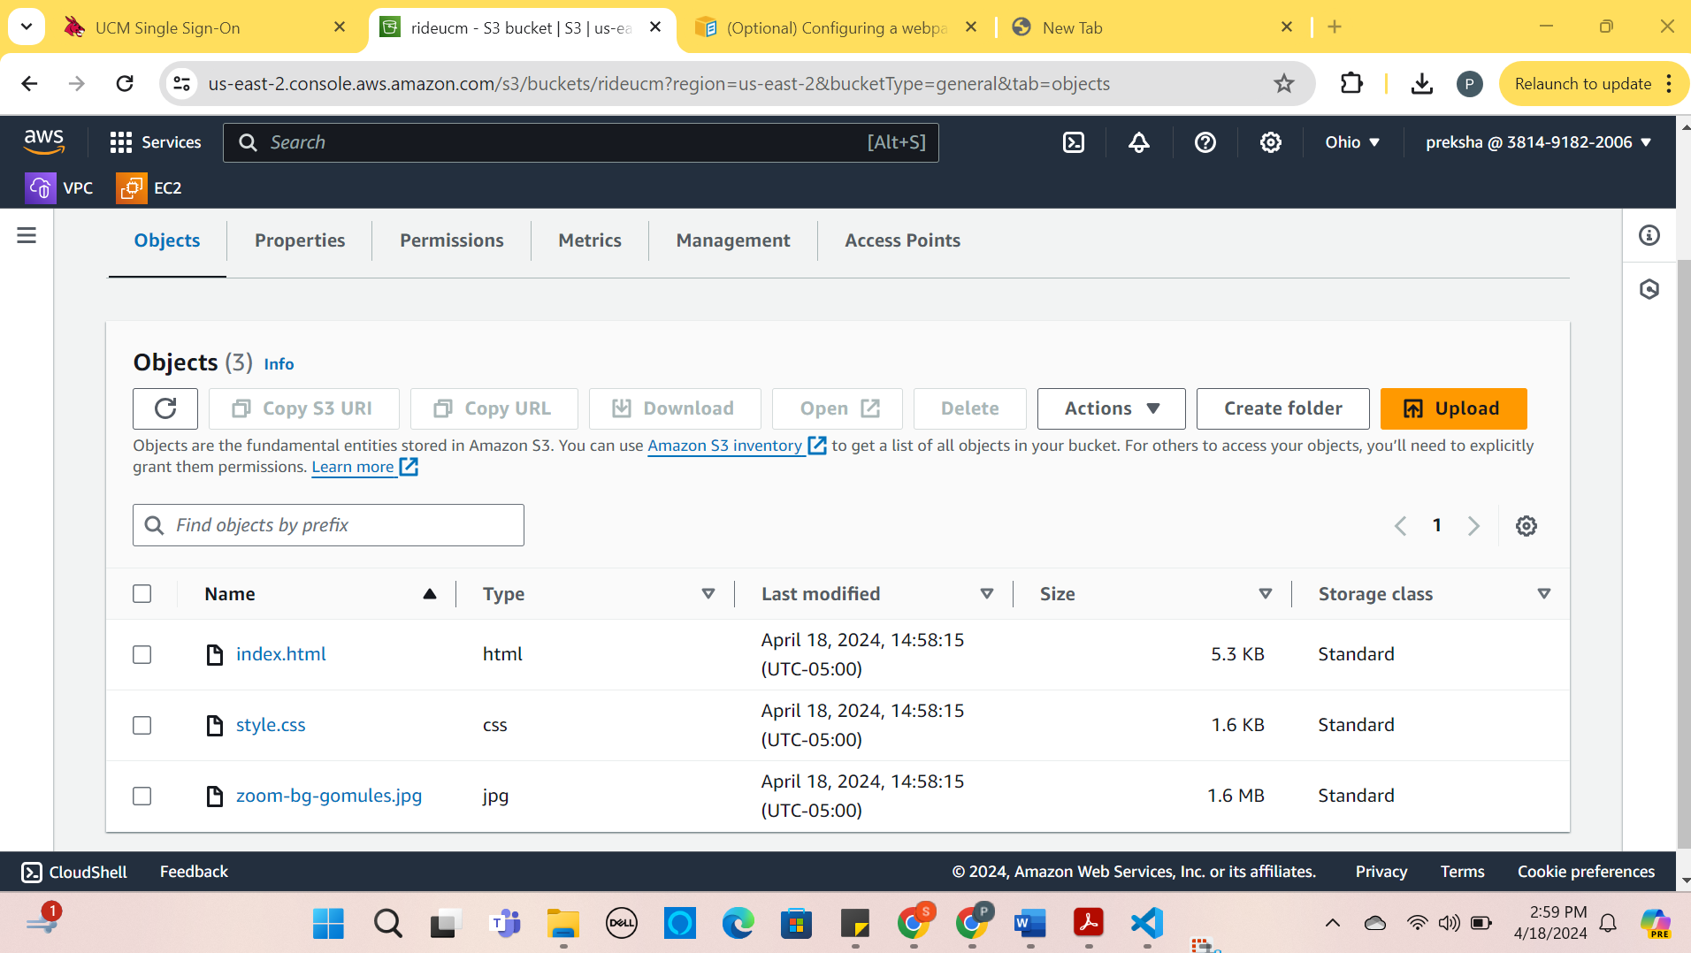

Step 4 : Access the static website using the endpoint url from S3

http://rideucm.s3-website.us-east-2.amazonaws.com/

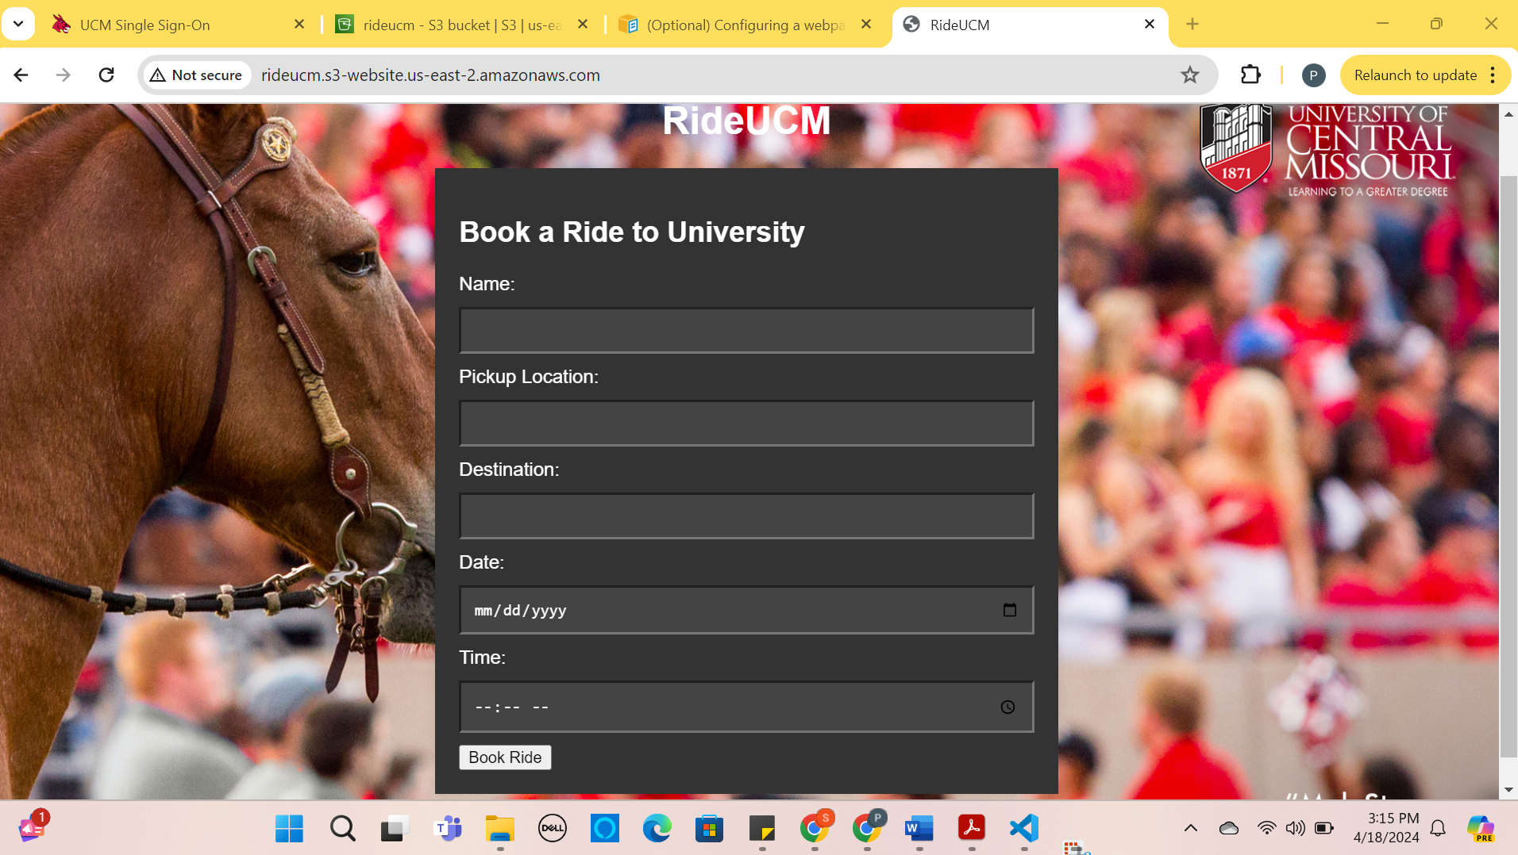

Using Amazon CloudFront distribution is used to launch our website globally:

How to create the distribution for the website rideucm:

* Choose the origin domain as the endpoint of the website from S3 Bucket.
* Select HTTP port 80
* The name of the origin would be the URL of the website.
* Default cache behaviour is set as it is.
* Cache key and origin requests is set to the S3.
* Click on the create distribution.

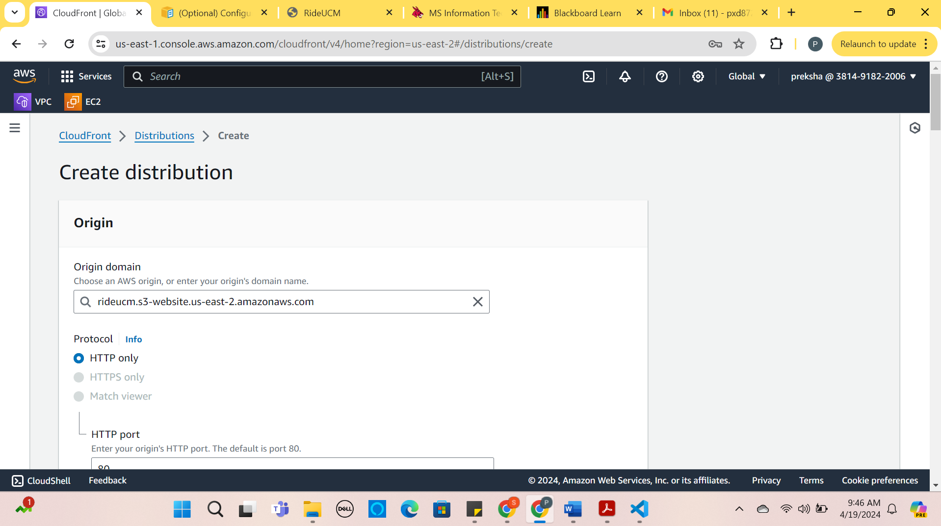

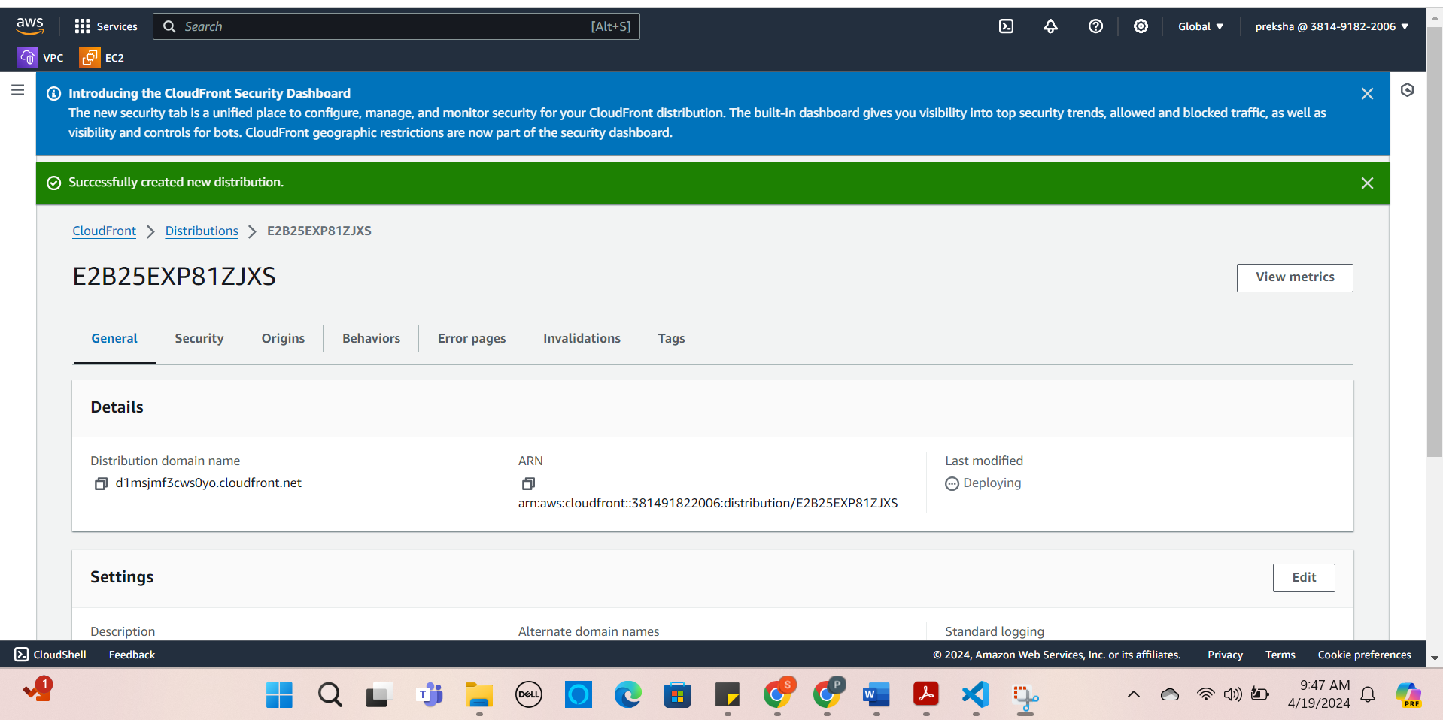

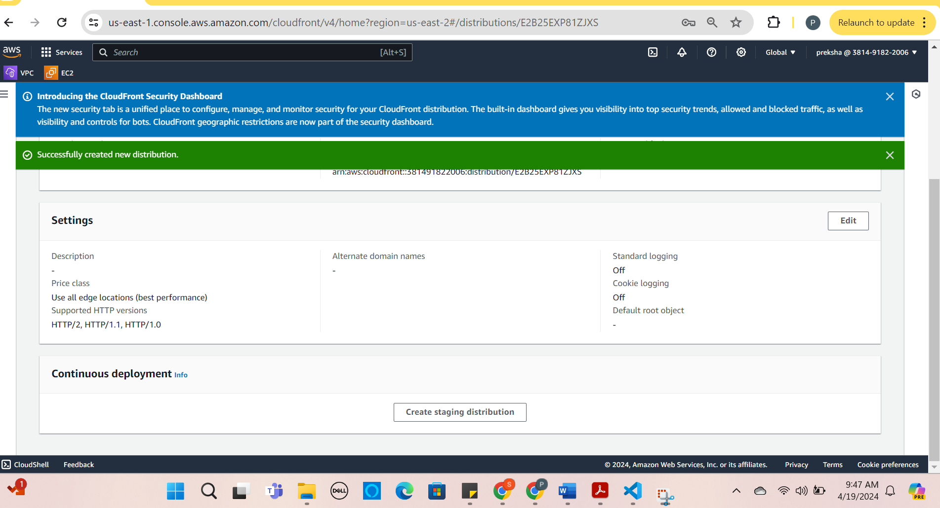

* Distributed Domain Name: <https://d1msjmf3cws0yo.cloudfront.net>

Continuous deployment sections in the CloudFront:

We can deploy or release the new content of the website at different edge locations and see it works.

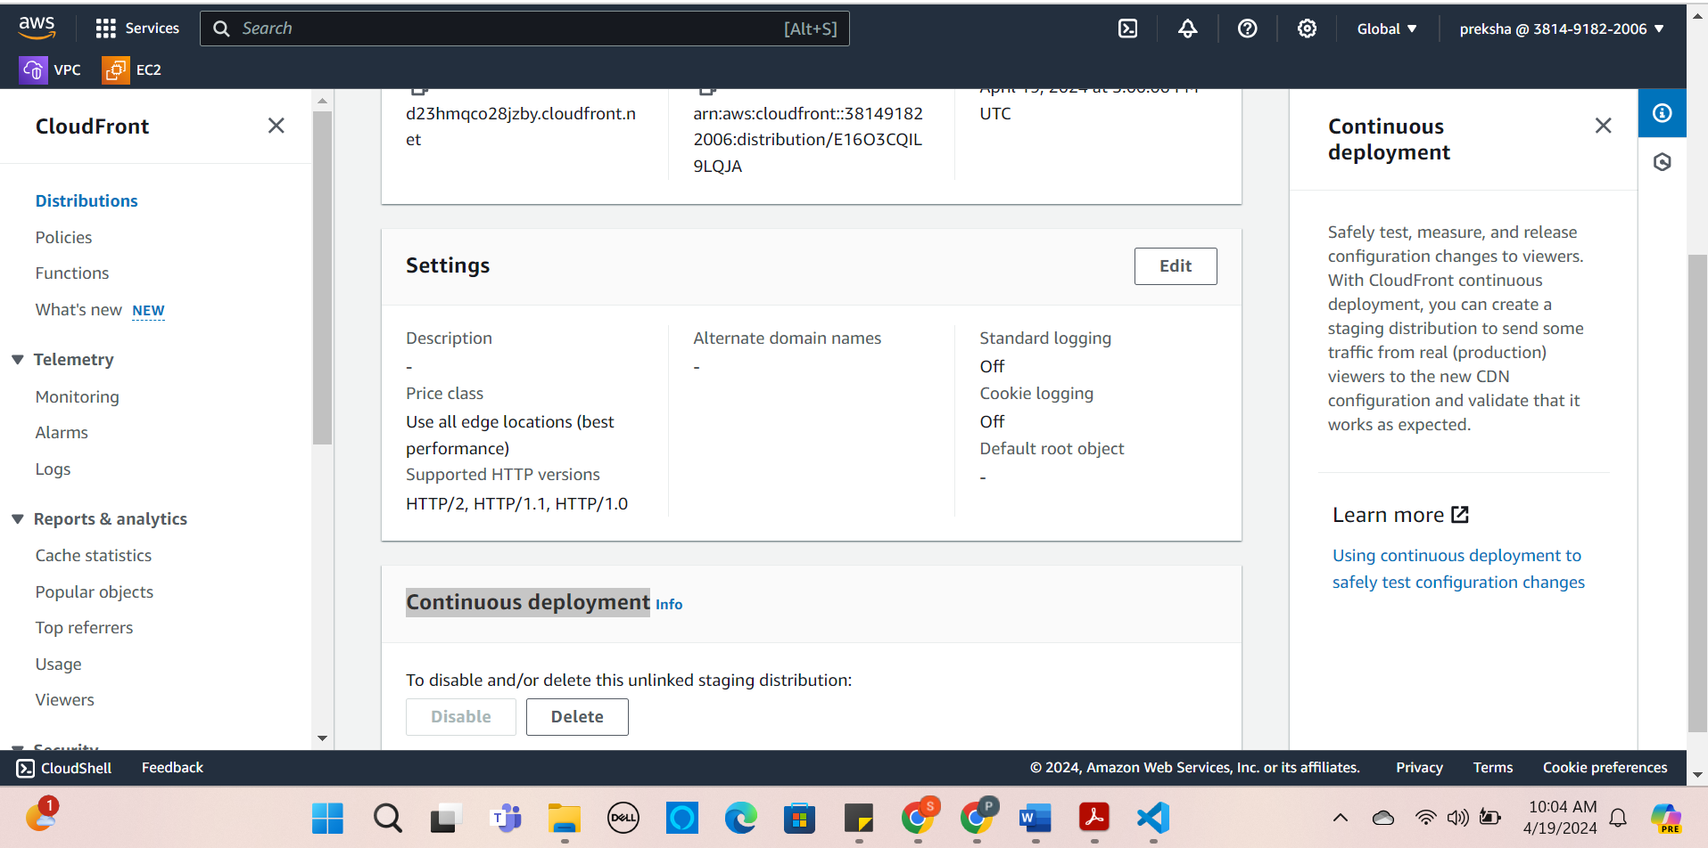

View Metrics:

This is a distribution metrics dashboard that shows the data of the website.

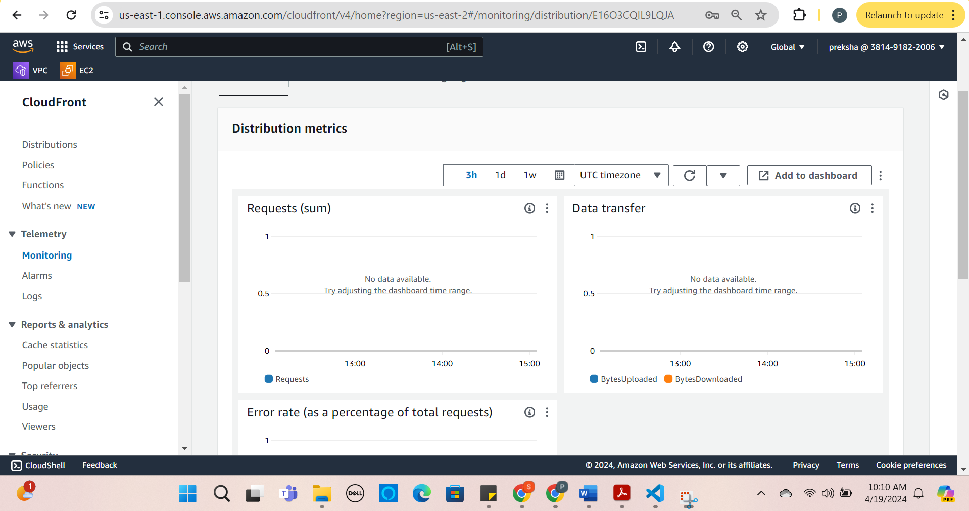

Creating **Amazon CloudWatch** for the website in the S3:

* Enable the server logs for the S3 Bucket.

Steps to do that:

1. Select the Bucket you want to set up Cloud watch for like rideucm.

2. Go to the properties tab navigate to the “server access logs” and click enable.

3. Select a Destination in our case that would be our Bucket

4. Click Save changes.

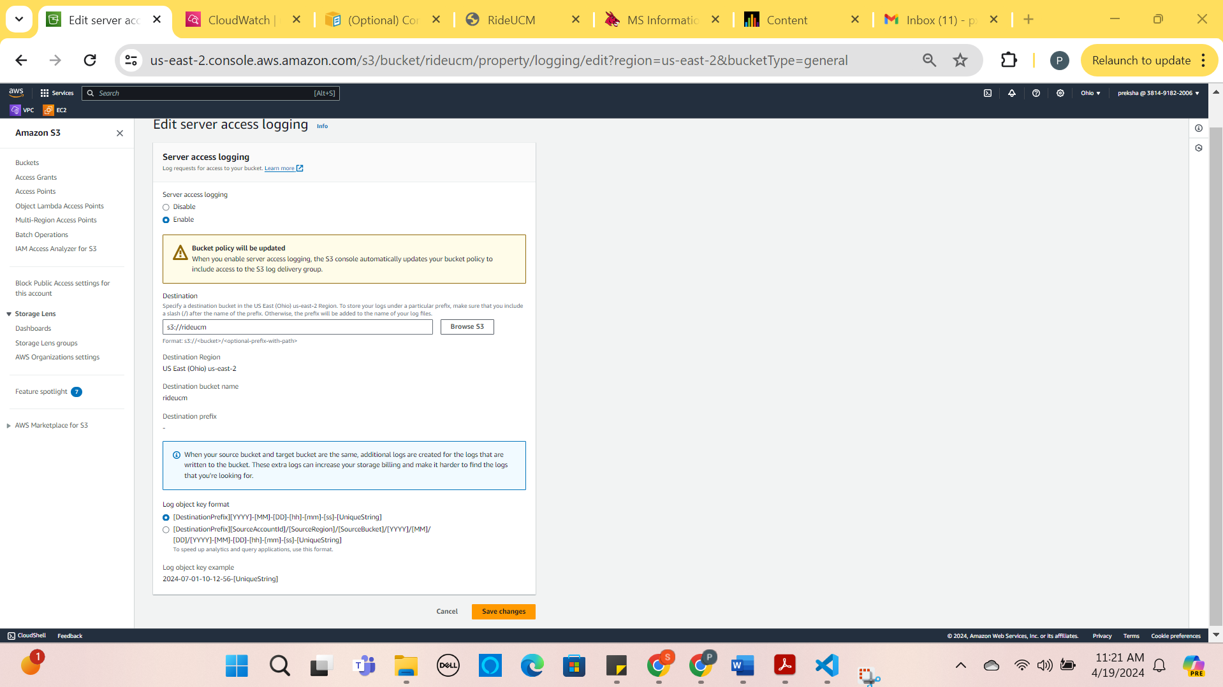

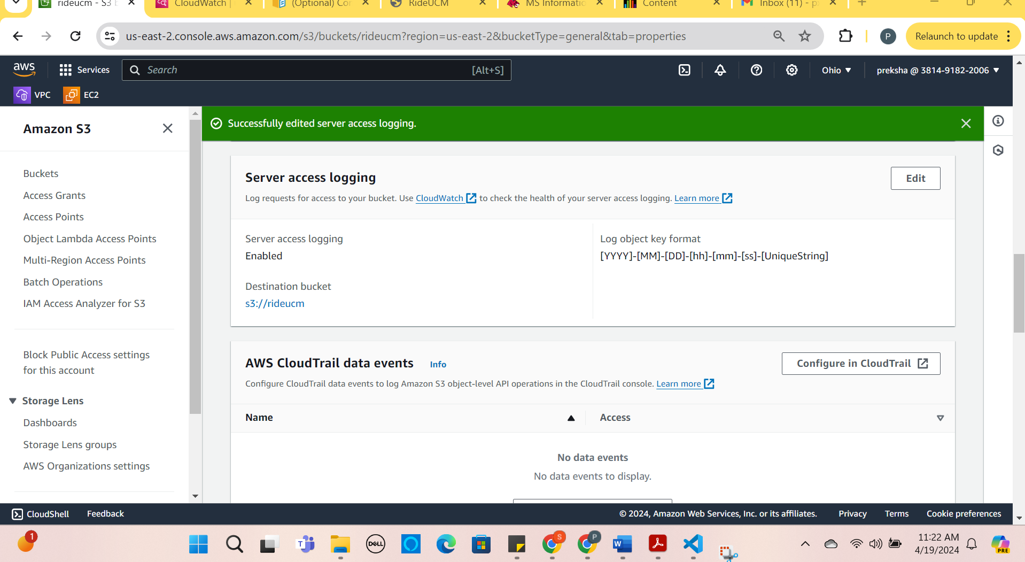

* Create a Cloud Watch Log Group:

1. Navigate to the cloud watch dashboard
2. Click on the log from the left panel.
3. Click on Create Log Group and enter the name of the log group and finish creating it.

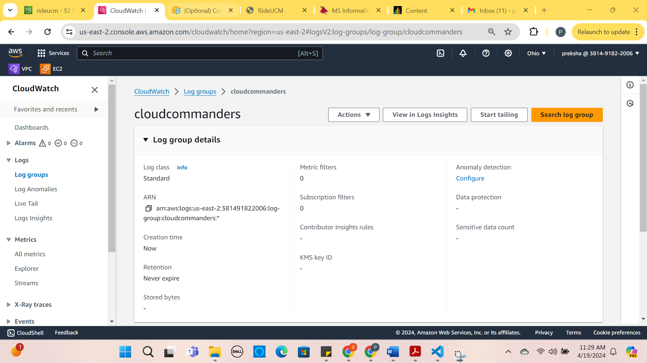

* Create CloudWatch Log Streams:

After creating the log groups now create log streams.

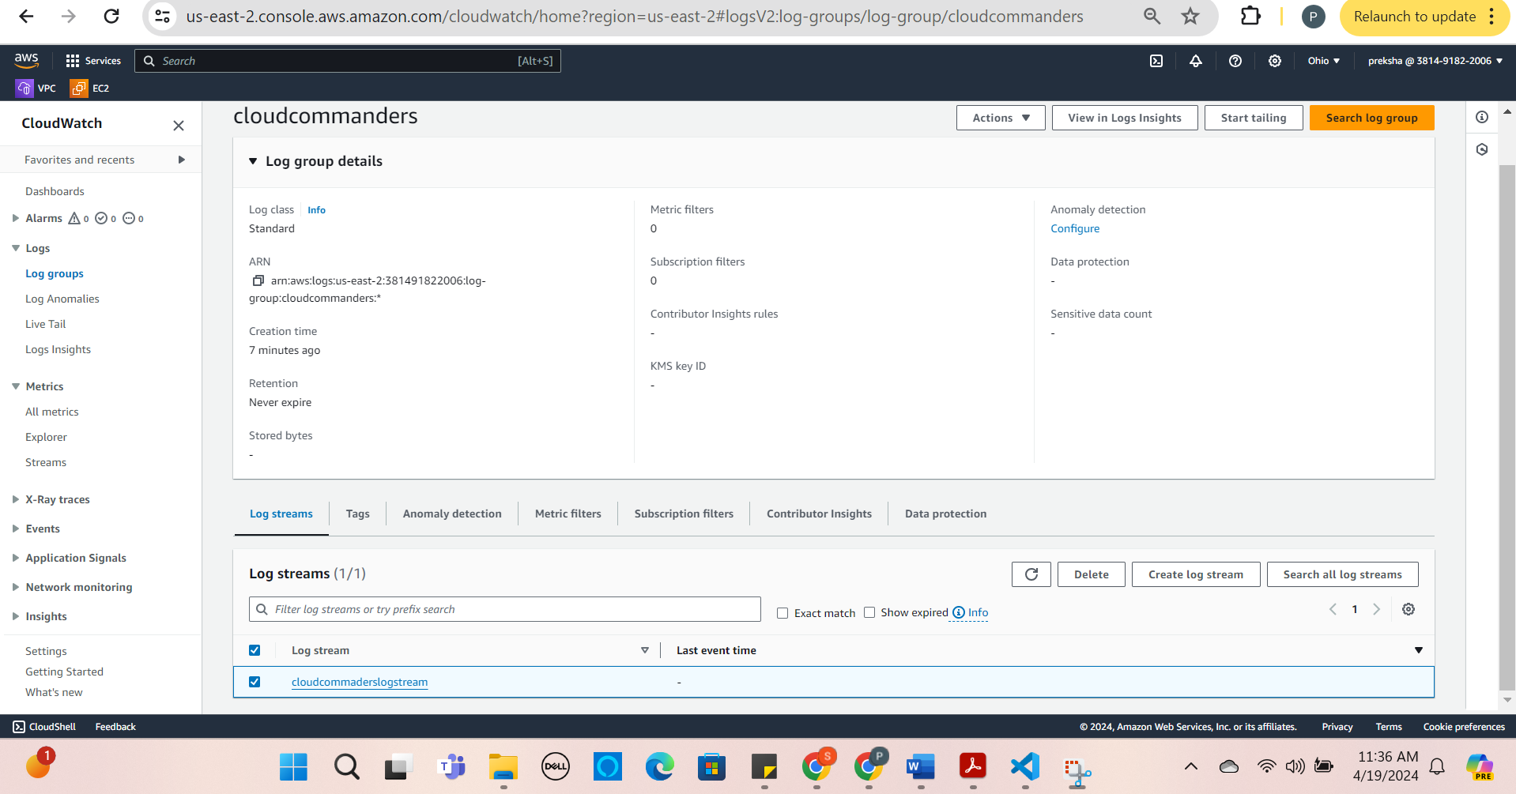

* Now Create CloudWatch Metric Filter:

1.In the log groups “cloudcommanders” click on the actions.

2. In actions click on the create metric filters.

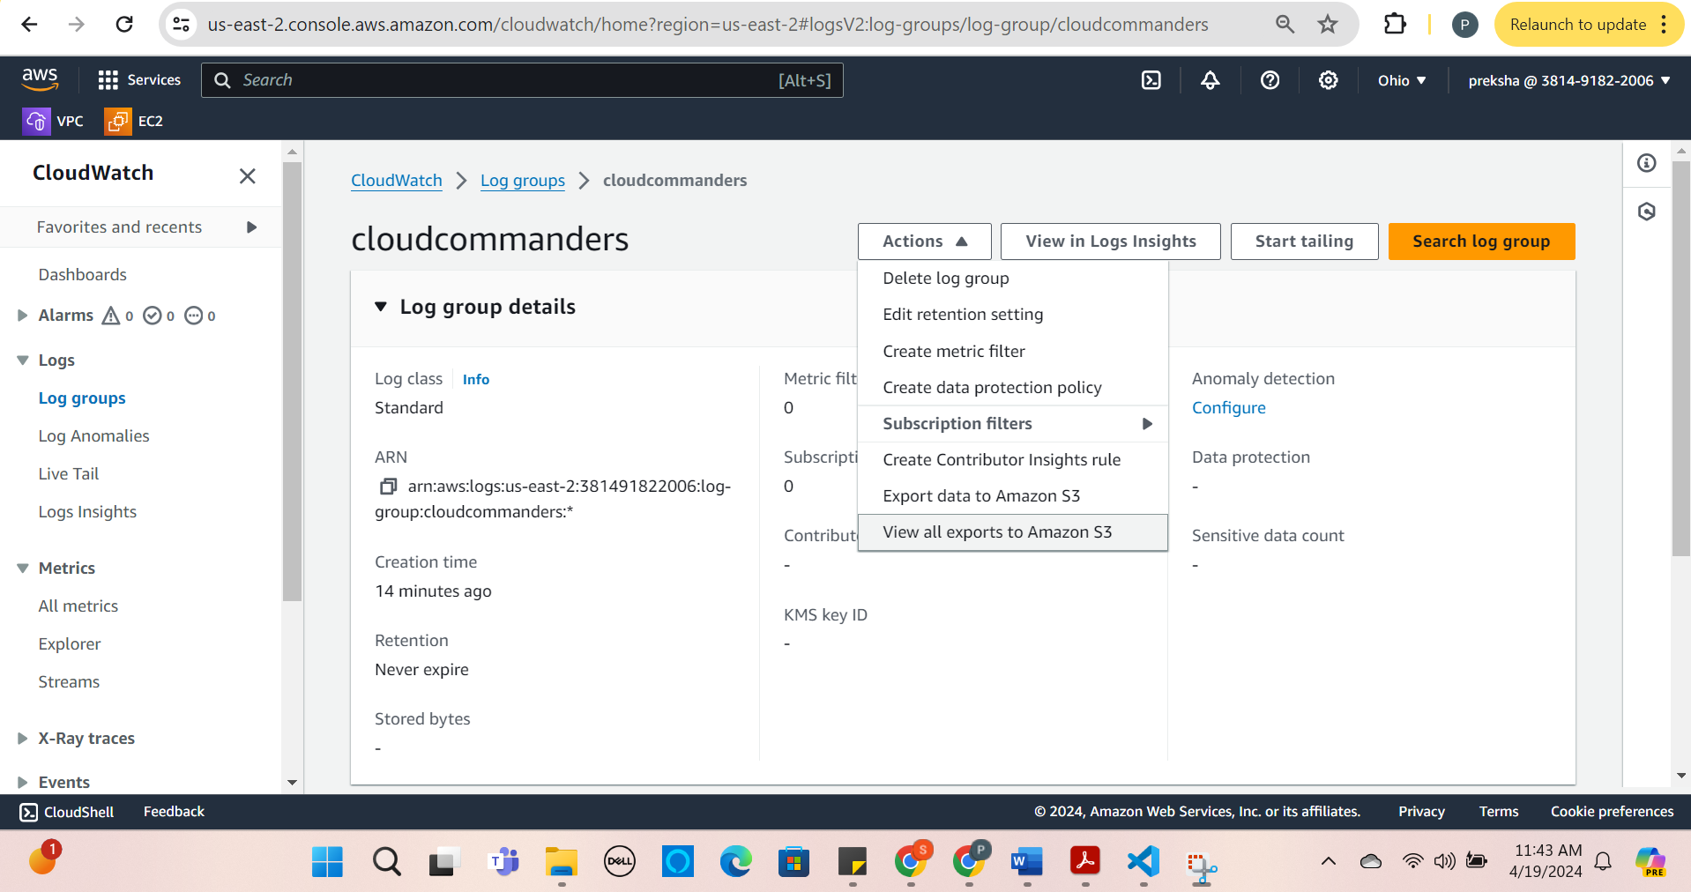

1. Define filter pattern.

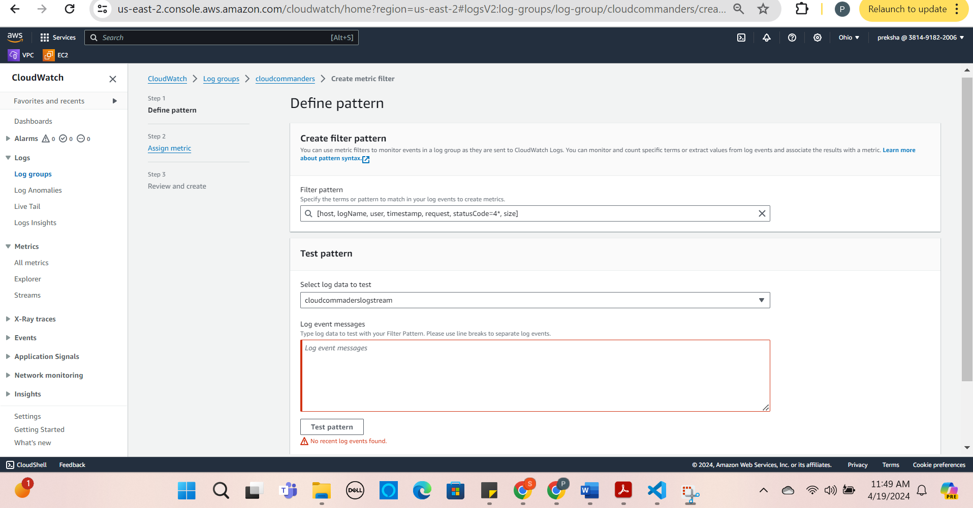

1. Assign Metric.

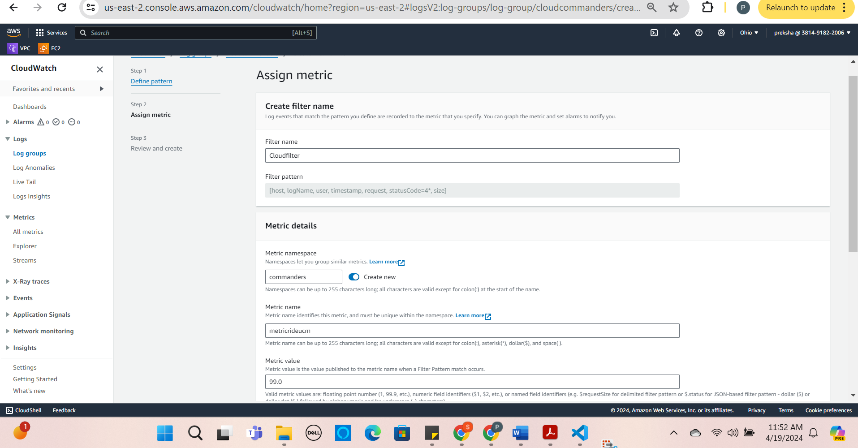

1. Review and Create.

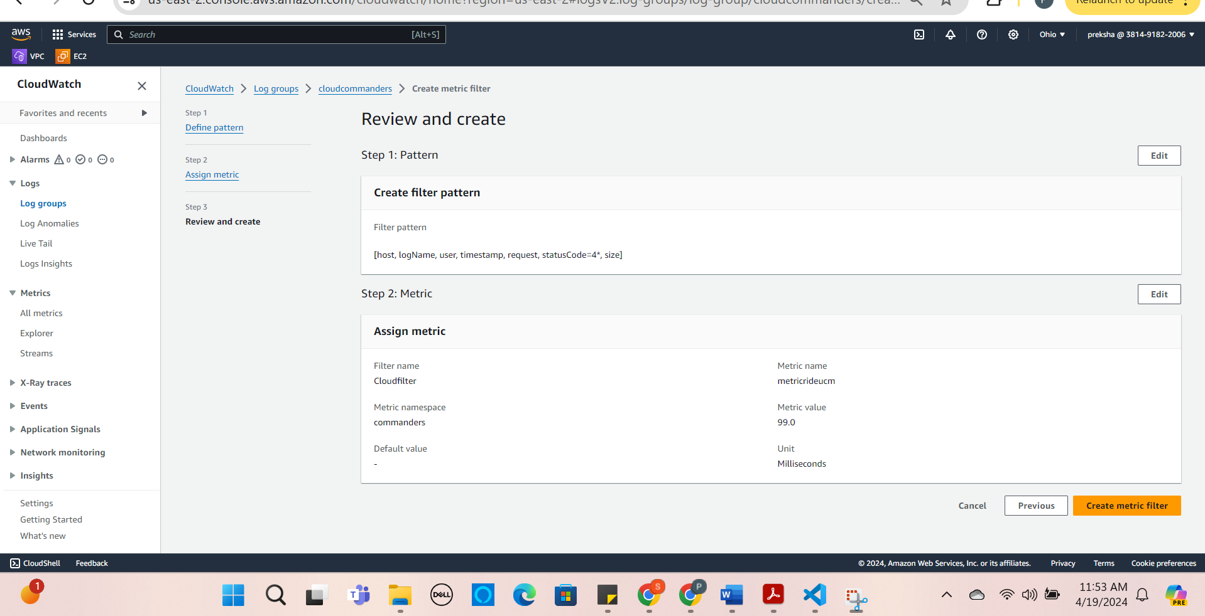

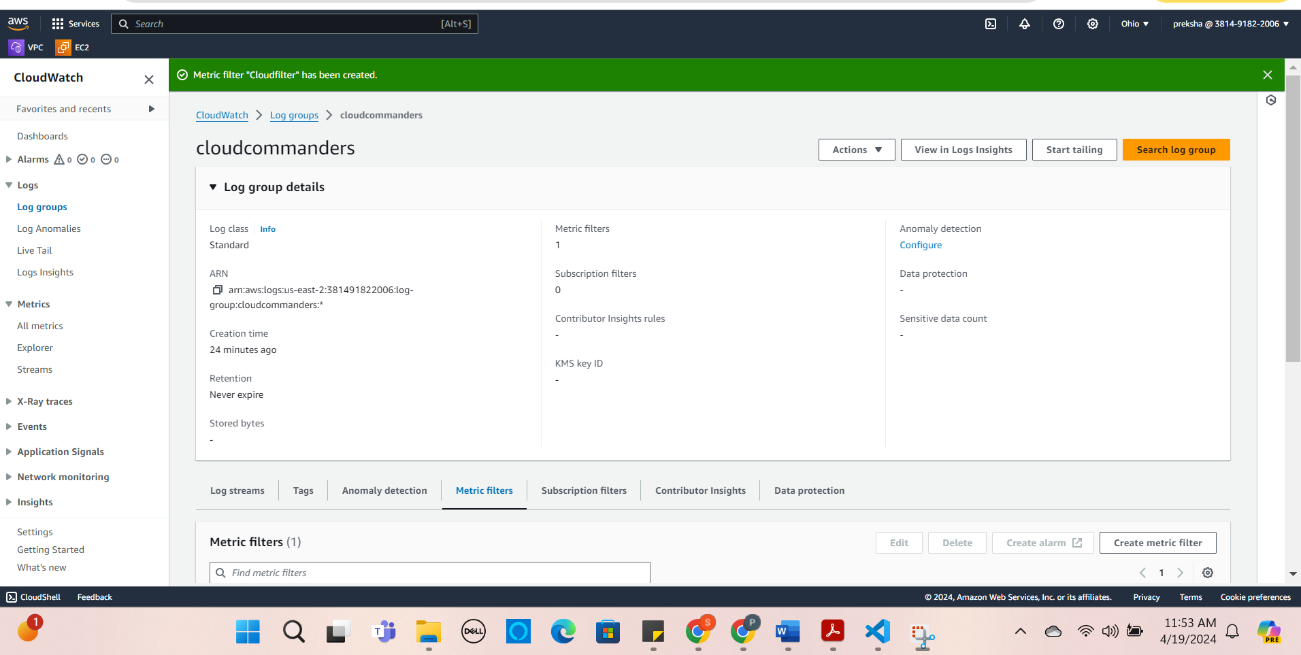

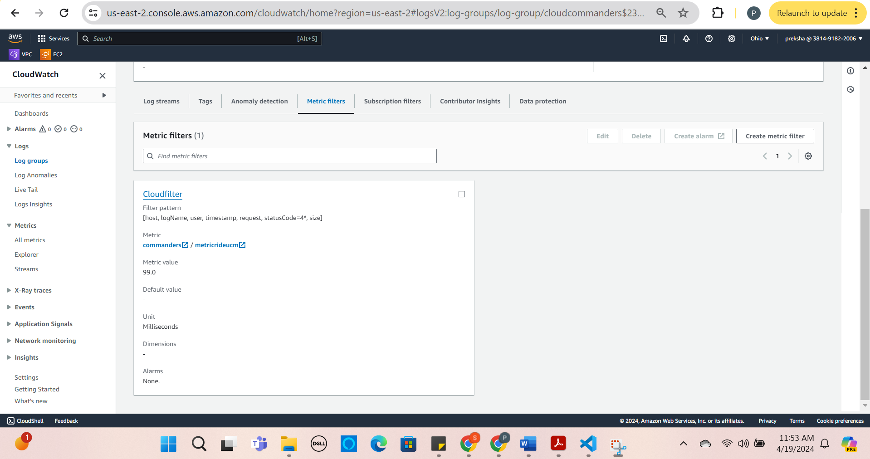

By setting this filter pattern and metrics, now cloudwatch will access logs from S3 Bucket. Now CloudWatch allows you to gain traffic flow and data flow of the website, performance, and issues when unwanted users access the website.

Creating a Domain name for the website using Amazon Route 53:

* Select Amazon Route 53 and click on Get Started.
* Choose Register a Domain.

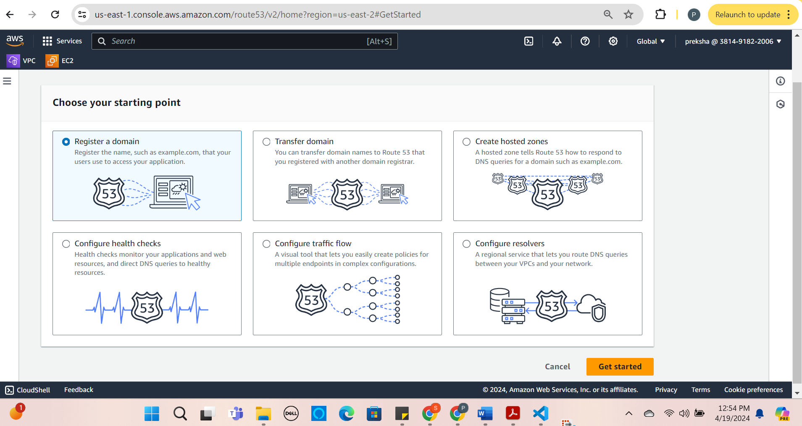

* Register Domains and select your FQDN for your website and click on select.

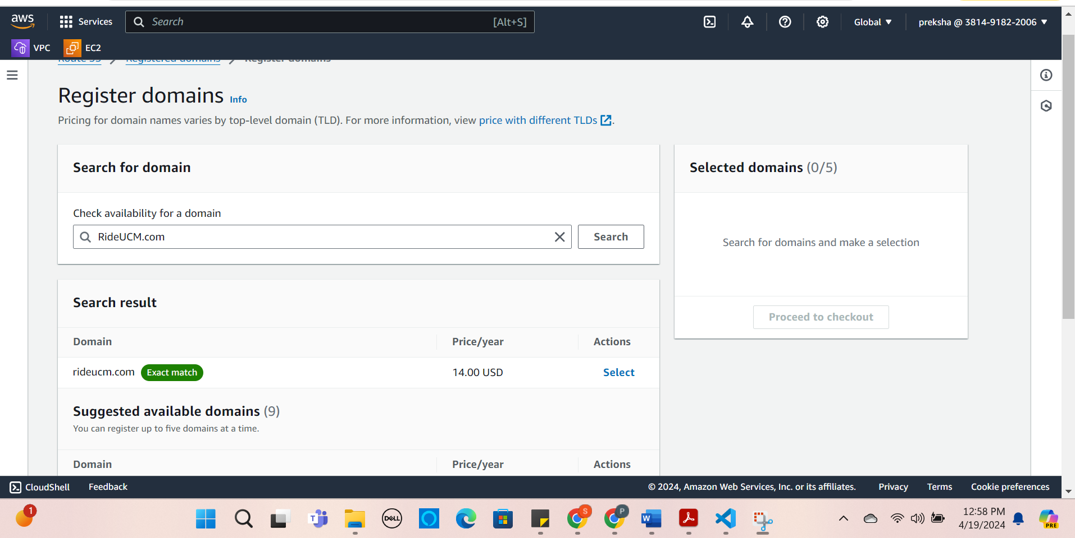

* Pricing for the domain name.

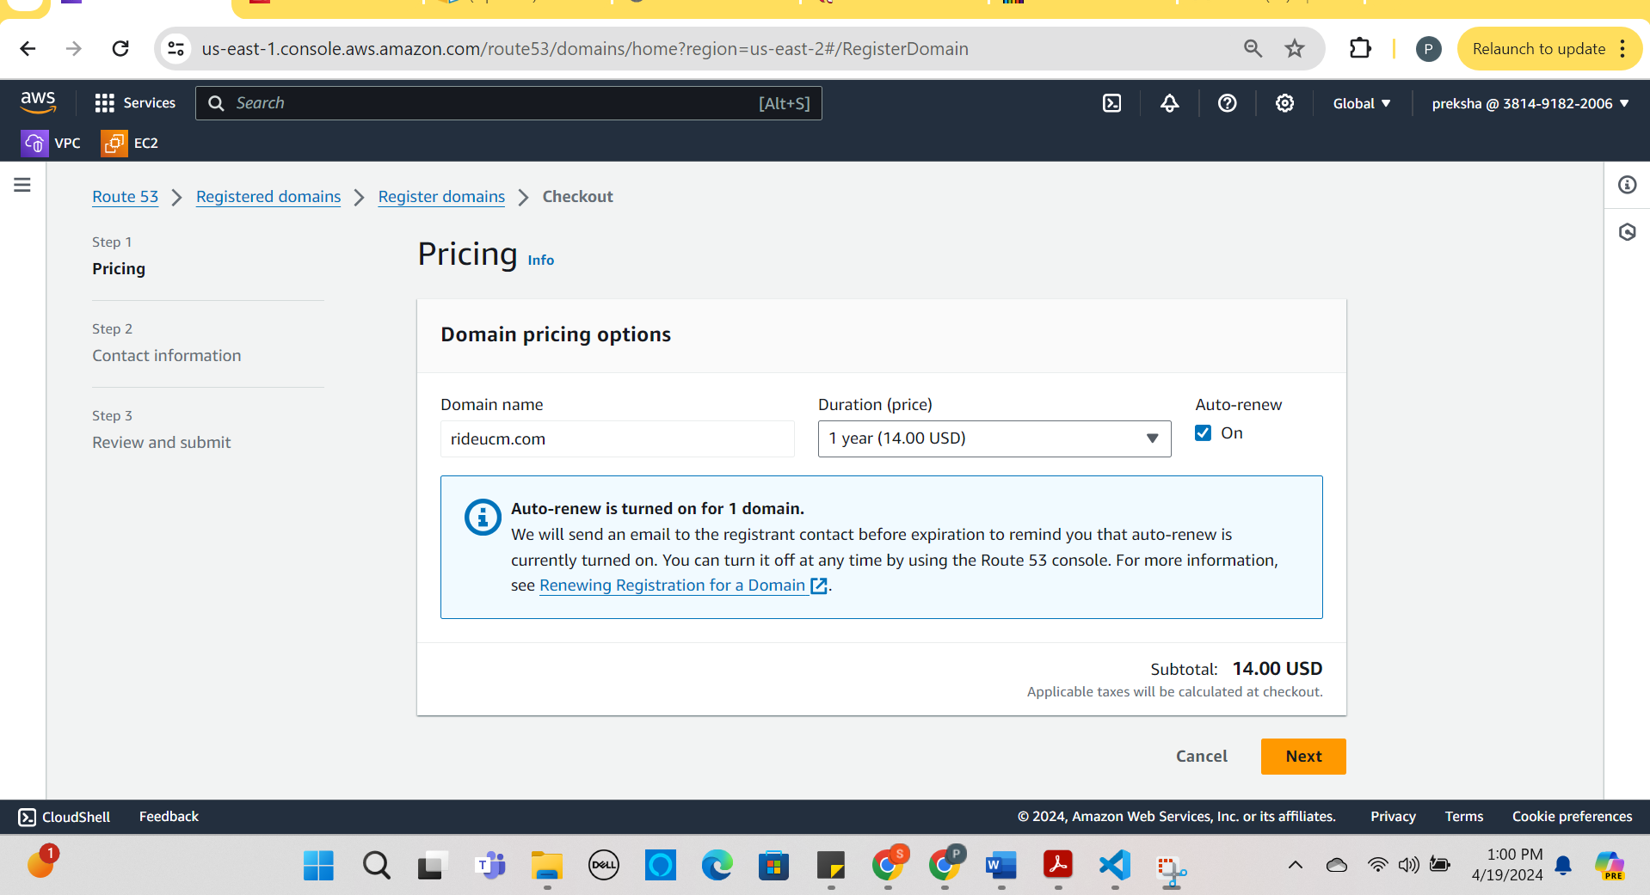

* The last step is Review and Submit an click submit.

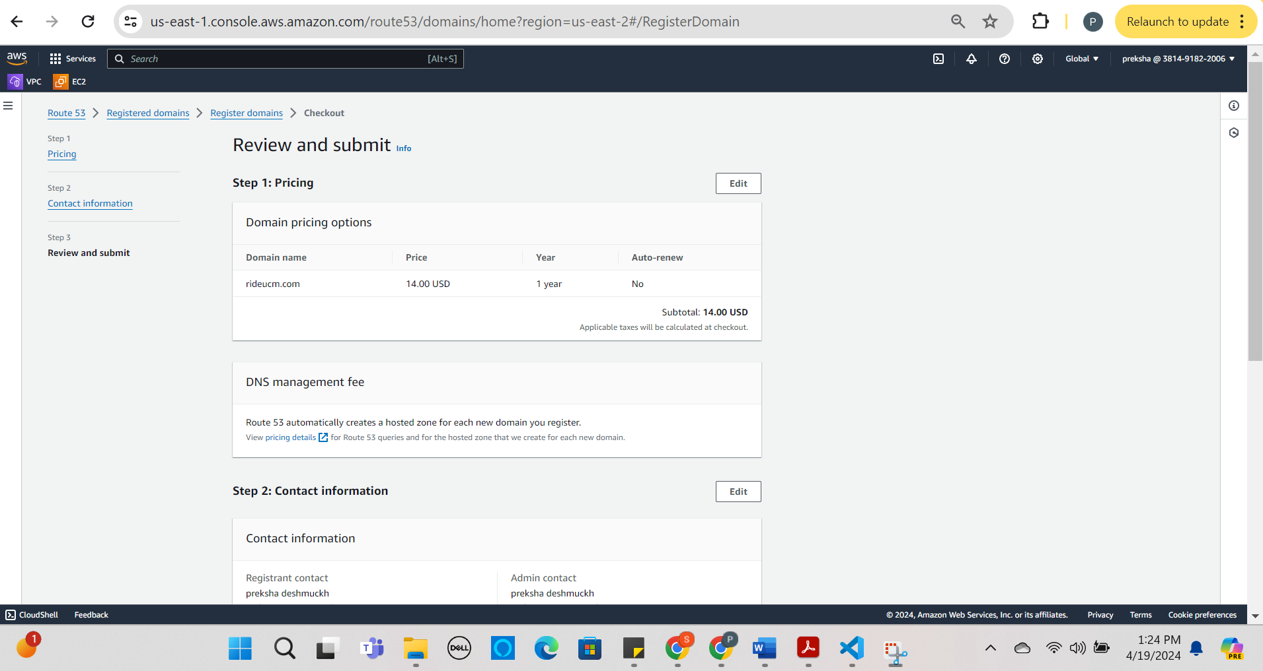

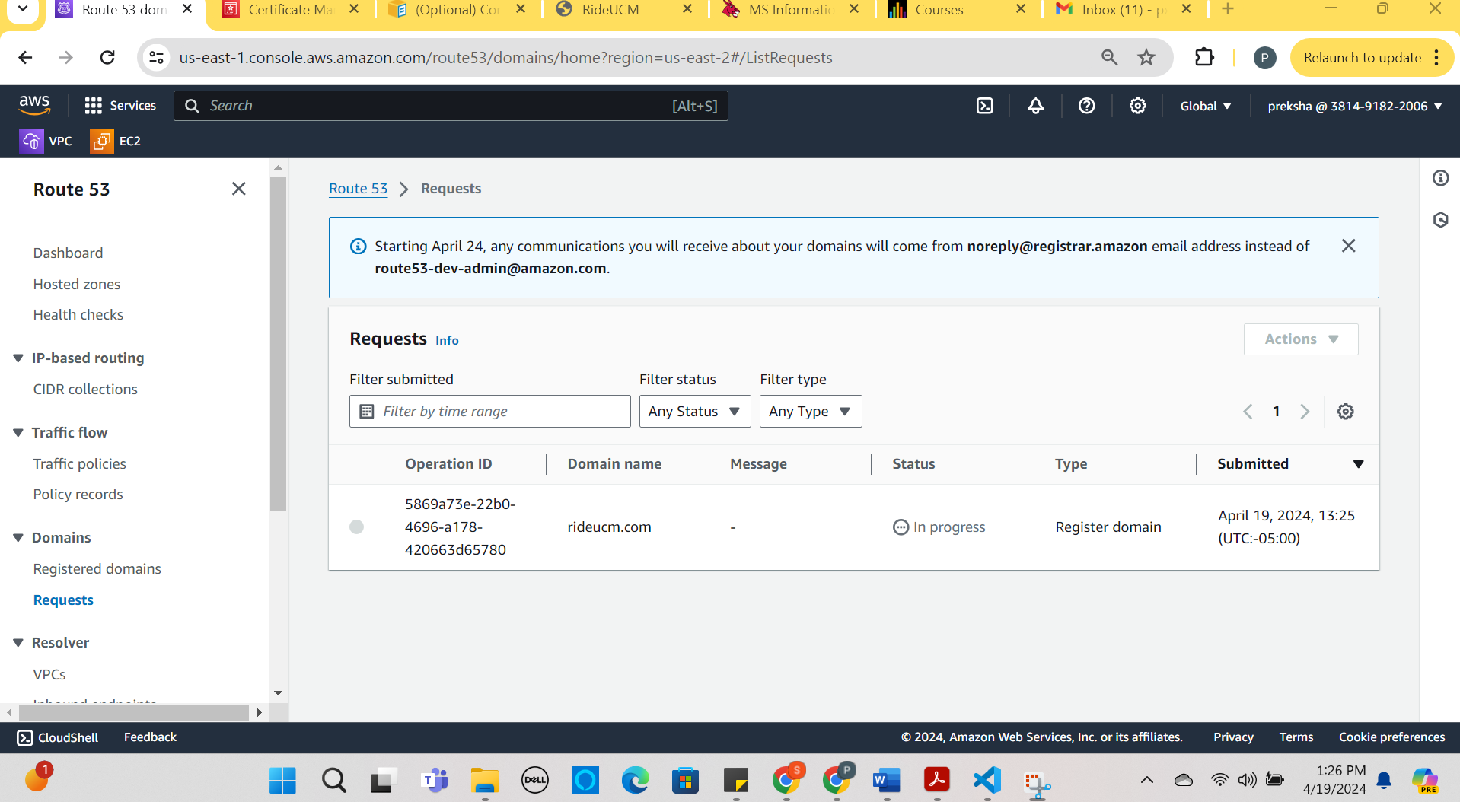

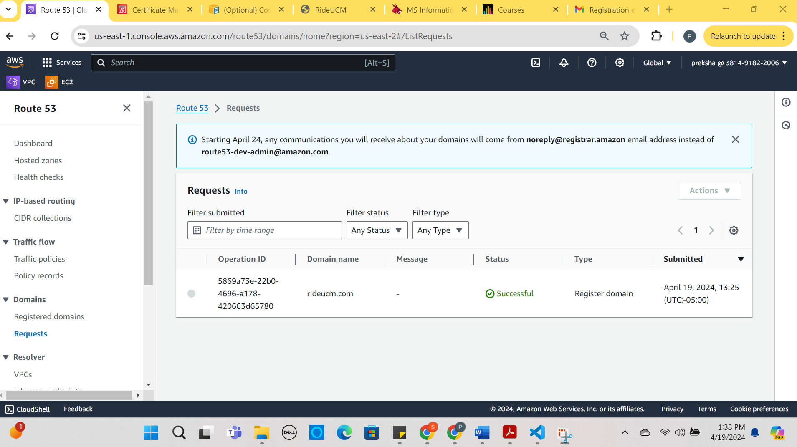

Setting Up the Amazon Certificate Manager for the static website Launched in S3 Bucket:

* Request a Certificate:
* Request a public certificate.

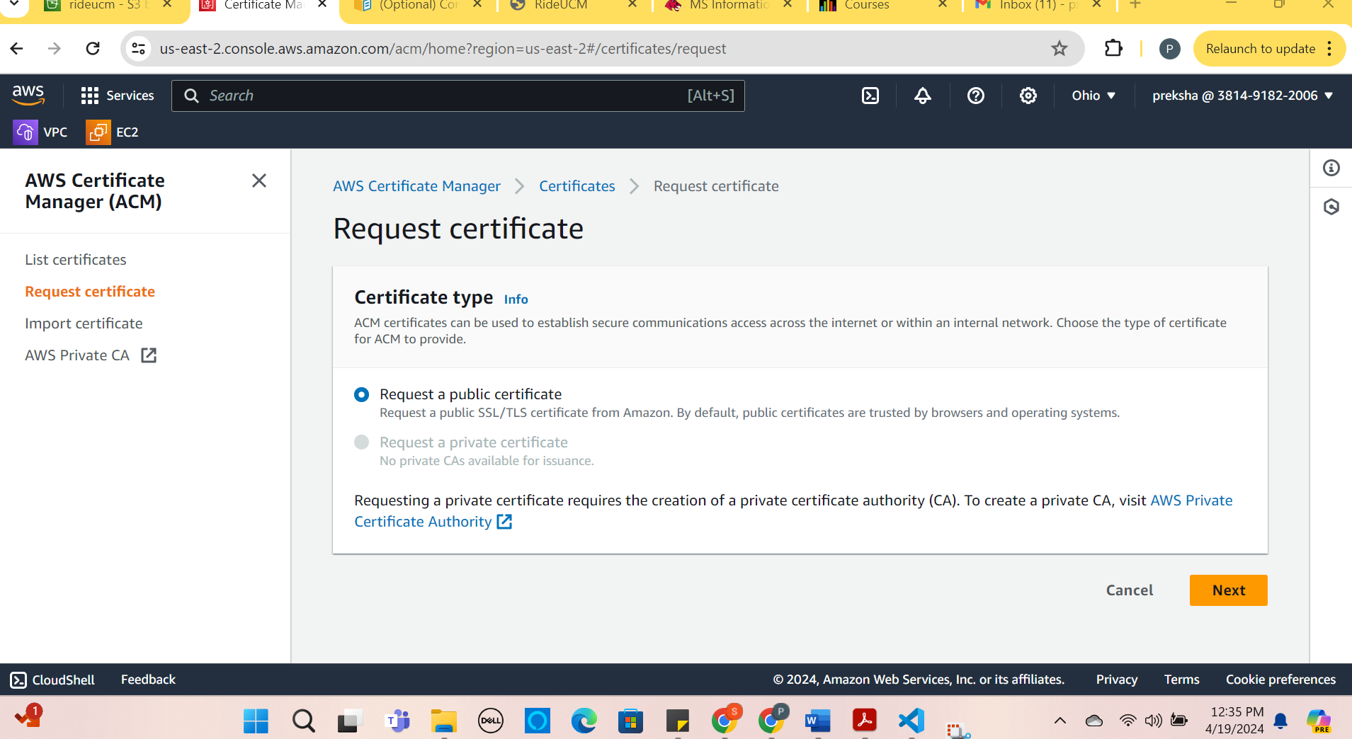

* Select Domain names example rideucm.com and which method for validating the certificate. The standard recommended to do DNS Validation. Click request

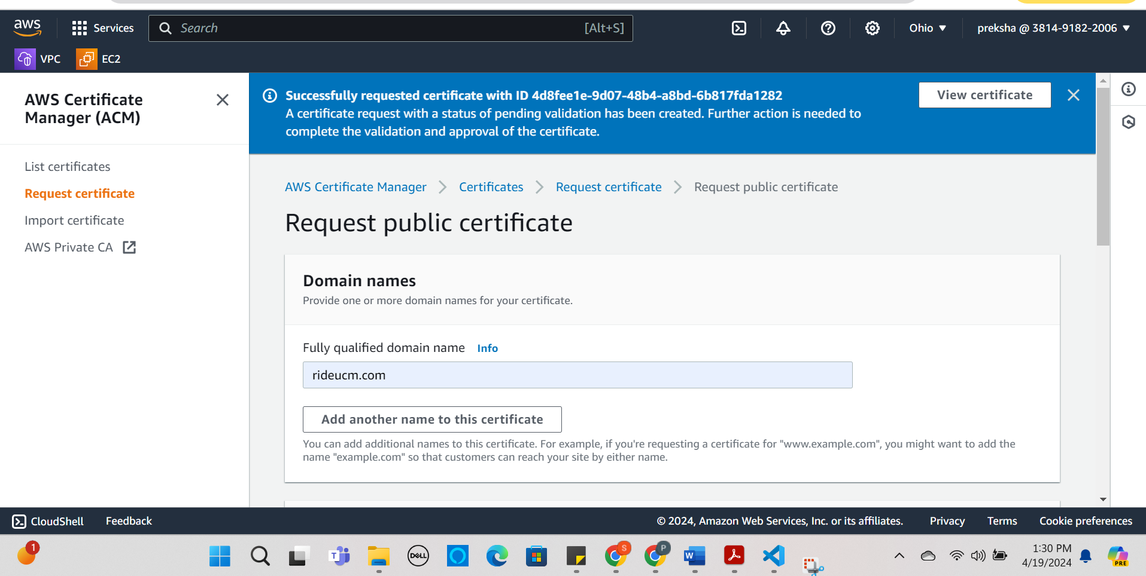

* Click on the view certificate.

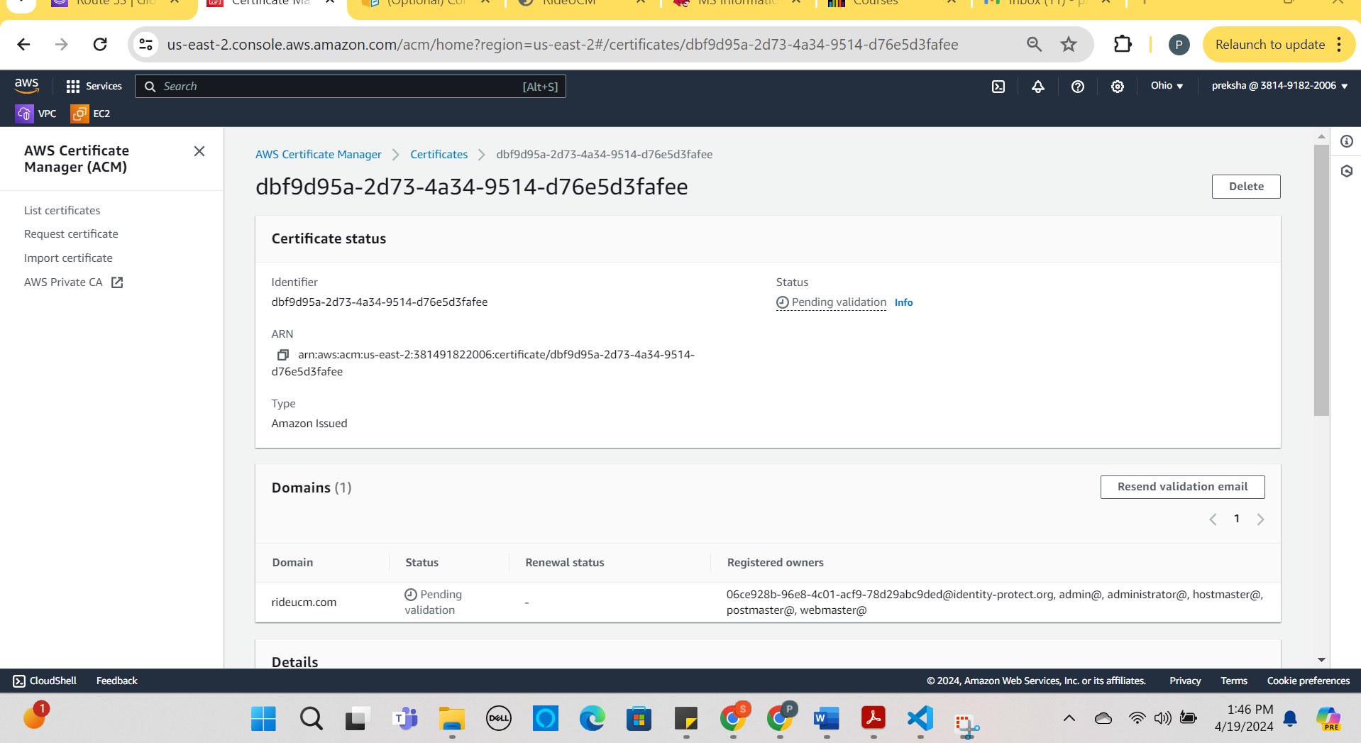

* For the Certificate to be issued we need to do one more step by making DNS validation.

1. Navigate to Route 53.

2. Select Hosted zones and click on Create Records.

3. Set the record type to CNAME.

4. The record name would be the subdomain of the certificate.

Example: CNAME:_5e8f713c148b1ed8d1590ff89015c046.rideucm.com.

Cvalue : _3e5bd5b6024a22221981e80601c43332.mhbtsbpdnt.acm-validations.aws.

5. Click on create records.

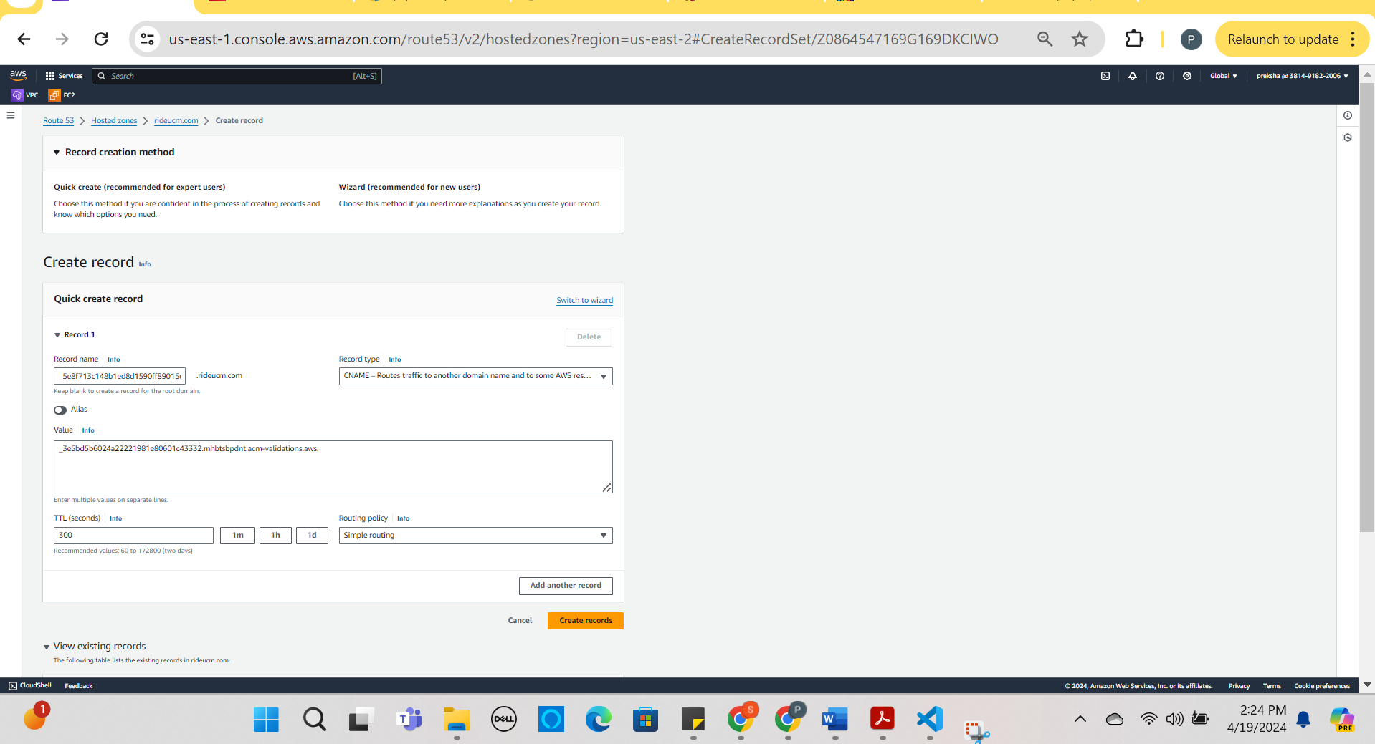

1. Record is successfully added.

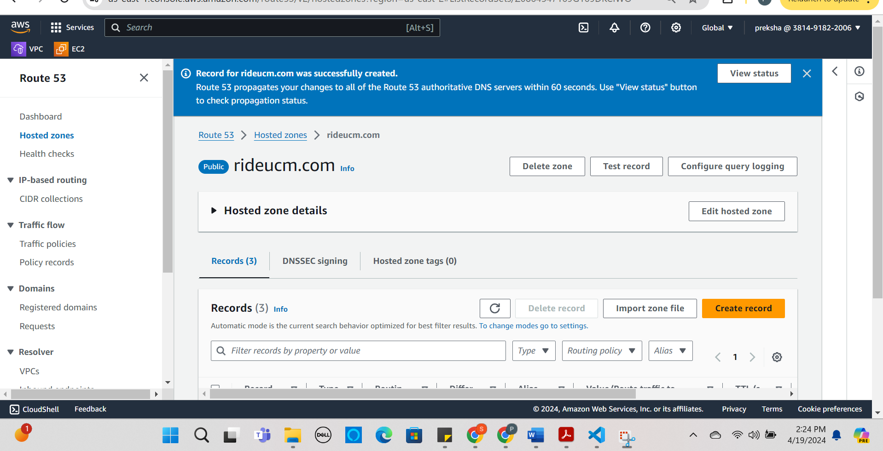

The above changes to the DNS configuration would take time. Once the CNAME record is updated Amazon Certificate Manager would be able to validate domain ownership and issue the SSL/TLS certificate.